*L**oRa & mesh integration*

*An expLoRational study into mesh networking with LoRa technology for SODAQ.*

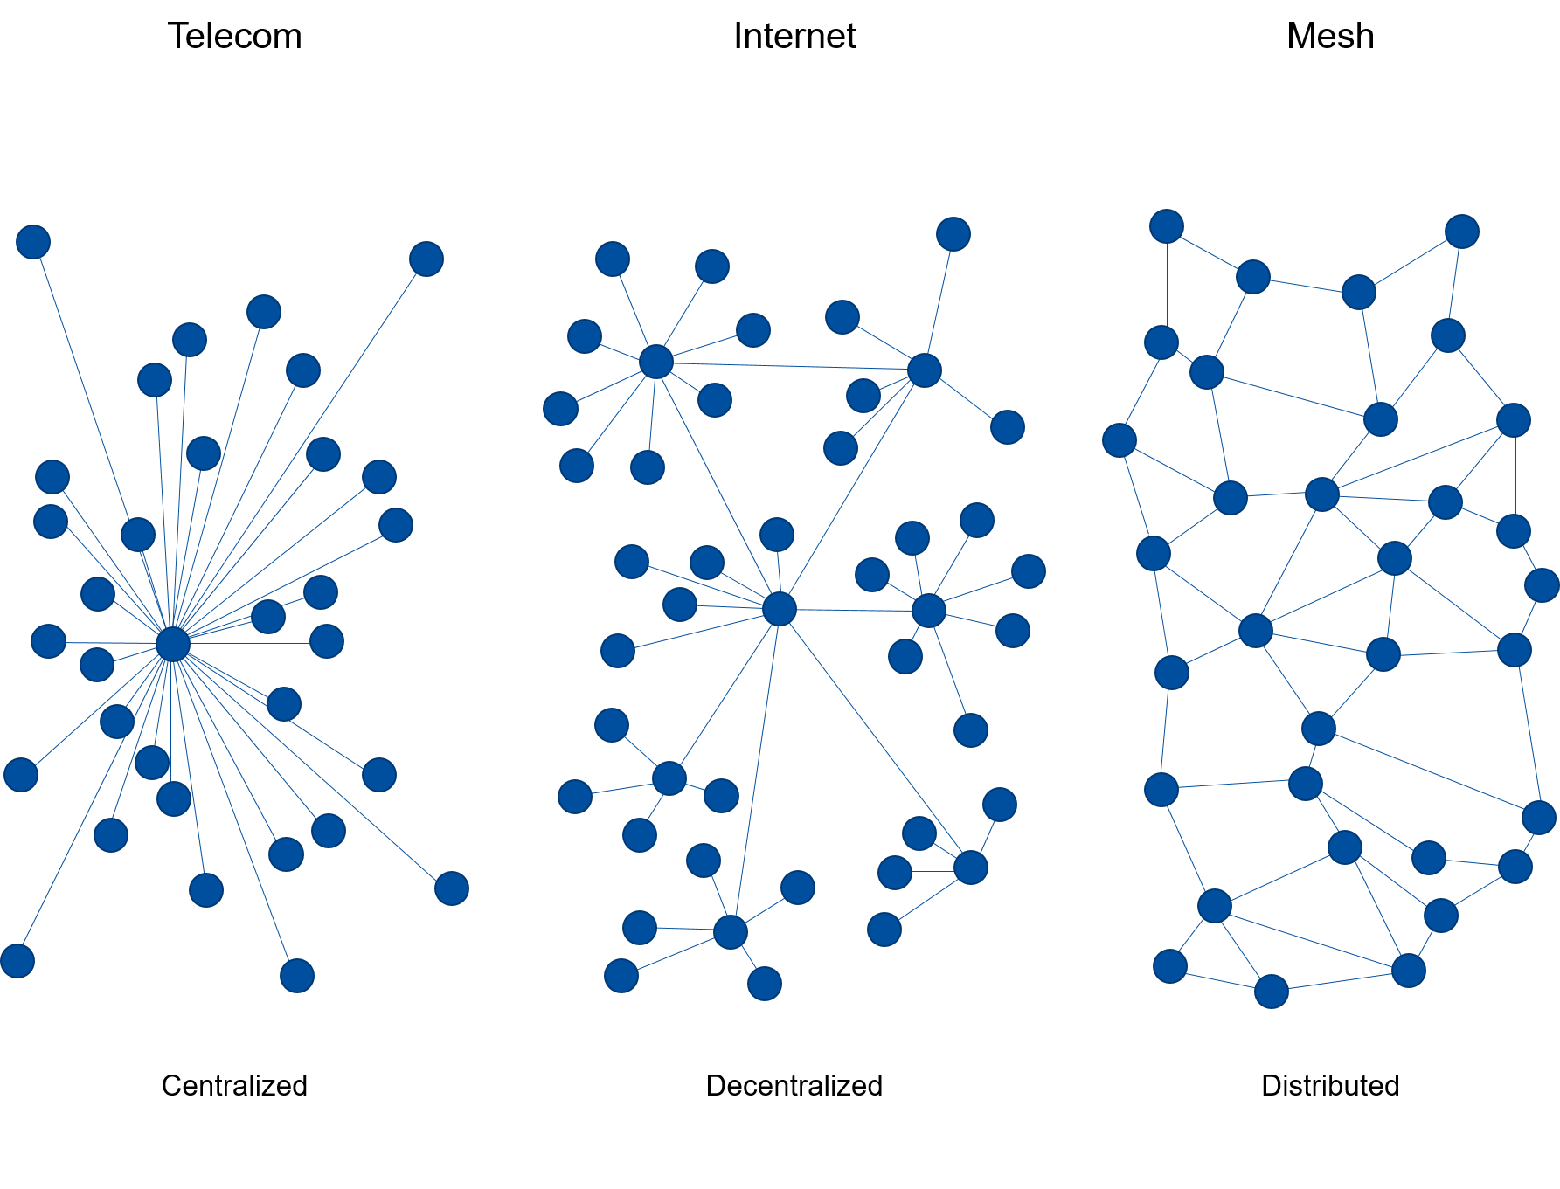

Date : 25-01-20211

Auteurs : Stijn Vergouwen  1682145

Maarten van Dijk  1744469

Nick Jans  1717809

Jari de Haas  1738478

Menno Weijers  1740474

Thomas Kinket 1732713

Assessors : Hubert Schuit

Johan Looijenga

Institution : University of Applied sciences Utrecht

Company : SODAQ Bussumerstraat 34, 1211 BL Hilversum

# Abstract

As a result of a collaboration between Hogeschool Utrecht and SODAQ a project was described for students to research the possibilities of LoRa mesh. After the orientation period the student team has formulated the following question to lead the project:

*“How can a synchronous power-state LoRa mesh network be realised for SODAQ applications? “*

This project is limited to the exploration and simulation of the possibilities regarding LoRa mesh and does not research hardware or expansive external factors. This project has been executed while following multiple different methods of working projects, this was caused by shifts in size and scope of the project, Business problem solving was the main method used for this report (Aken, 2007).

This report concludes that the use of LoRa mesh in its current form is not commercially viable nor desirable from a technical perspective. Though in some niche cases it can prove to be necessary sometimes. Finally SODAQ is advised to not consider LoRa mesh as a desirable technology for their everyday products.

# Table of contents

Abstract 1

Table of contents 2

1 Preface 4

2 Project description 5

2.1 Company description 5

2.2 Problem definition 5

2.3 Project scope 8

2.4 Results and deliverables 9

2.5 Potential customers 11

2.6 Strategic importance 13

3 Analyses & diagnoses 14

3.1 Possible applications for a viable for LoRa mesh in a commercial setting 14

3.2 Necessary parameters to develop a LoRa Mesh network 15

3.3 Regulations, legislation and external factors that influence the application of LoRa mesh 17

3.4 Existing LoRa mesh protocols for the simulation 20

3.5 Which method is best suitable for keeping individual nodes synchronized? 24

3.6 Limitations of the LoRa Mesh network? 24

3.7 Realizing a LoRa mesh simulation 27

3.8 Conclusion analyses & diagnoses 33

4 Program of requirements 34

4.1 MoSCow method 34

4.2 Requirements 34

5 Solution design 38

5.1 Final parameters 38

5.2 World regulations/standards 39

5.3 Evaluation of the protocols 40

5.4 Synchronizing the nodes 42

5.5 Comparison LoRaWAN and mesh 43

6 Project management 45

6.1 Project methods 45

6.2 SCRUM 46

6.3 Member roles 46

6.4 Milestones 46

7 Conclusion & recommendation 48

7.1 Conclusions Regarding LoRa Mesh 48

7.2 Conclusions Regarding the use of LoRa Mesh 49

7.3 Recommendations regarding further Research 49

7.4 Recommendations regarding commercial application 50

Bibliography 51

Attachment 1 Phone call Centraal Beheer Achmea 55

Attachment 2 Persona canvas 56

Attachment 3 Current draw SX1276 & SX1262 57

Attachment 4 Flowchart LoRaSimSODAQ.py 59

Attachment 5 Different legislation regions. 60

Attachment 6 Simulation experiments excel sheet 61

Attachment 7 Sprint report 64

# Preface

This project was initiated based on the wish of SODAQ to create a LoRa mesh network. These are to separate networks which combined would have an increased range without the need of using extra gateways. This could save money in terms of placing gateways while having nodes send information to one another.

The problems with this project however arose out of the fact that without a clear use case it is nearly impossible to develop any practical system with additional hardware. This combined with the fact that having nodes sending information to each other could potentially lead to a high-power drain of the nodes. This given due to the fact that the nodes need to communicate with each other.

The goal of this report is to answer the following question:

*“How can a synchronous power-state LoRa mesh network be realised for SODAQ applications?”*

This question will be answered based on the on the desk research that has been concluded by the project group. The scoping of this project limits itself towards the development of a functioning simulation without any practical tests or hardware.

The structure of this report goes as follows. Chapter 2 contains the entire project description including SODAQ and everything related towards the project. Chapter 3 exists out of the analyses & diagnoses with the research questions. Chapter 4 contains the program of requirements. Chapter 5 is the solution design. Chapter 6 discusses the project management methods used during the project. Lastly, chapter 7 will mention the conclusion & recommendation of the research done on the main question.

# Project description

In this chapter the project, premise and SODAQ will be discussed to establish a common baseline for all readers. Paragraph 2.1 discusses SODAQ as a company. Paragraph 2.2 contains the problem definition. Paragraph 2.3 includes the project scope. Paragraph 2.4 contains the research questions under the results and deliverables. Paragraph 0 talks about the potential customers. The final paragraph 2.6 talks about the strategic importance.

## Company description

Solar Powered Data Acquisition or SODAQ for short, is a company founded in 2013 with the goal to reduce battery usage around the globe. They aim to achieve this by developing low/solar powered products that only send out data when required.

The organization has set its mission on developing intellectual property, knowledge, expertise, software, hardware, proof of concepts and prototypes. Whilst turning these ideas/products into physical, effective and widespread products/solutions. With this preferring what to make products from biodegradable materials.

SODAQ aims to be an extension of IoT departments for other companies, this implies that the companies main focus is to generate ideas (SODAQ, 2020). This focus lies throughout the several different industries, which will be expanded upon in sub paragraph 2.1.3 customer segmentation.

### Organization

SODAQ as an organization has a flat and accessible structure, with less than 30 employees the management of 6 people are a significant part of the company. They are highly involved with the running of the business on an operational level.

Consisting of three separate companies SODAQ assumes a standard corporate structure with one holding company and two subsidiaries. Due to the size of the company not much else is known about their inner structure and workings.

### Products SODAQ

SODAQ does have a small product line tailored towards the different industries that the company is active in. These products are built around the IoT network. They make use of LoRa or make use of GPS trackers for cattle. Their product range includes multiple kinds of products which SODAQ themselves split into five categories (SODAQ, 2020):

* Life tracking
* Environmental sensing
* Development boards
* Industrial monitoring
* Asset tracking

## Problem definition

SODAQ makes use of Long Range Low Power (LoRa) modules in their products, these are meant for long range and low power applications. This form of communication does not rely on 4G or Wi-Fi, but on gateways with a limited range. The basic principle behind this network is that individual nodes send their gathered data towards the gateway(s).

SODAQ wants to combat this shortcoming in terms of range by adding a mesh network on top of a LoRa network. Mesh allows the nodes used to communicate with each other (Bankole, 2018).

### Customer segmentation

The customers of SODAQ will be segmented based on Customer sophistication. This means that they will be divided based on their industry and services (Soffer, 2019). The reason for this being is that SODAQ has listed its customers on their website, from there on these companies can be easily categorized to seek out similarities (SODAQ, 2020). These can be categorized like as governmental or agricultural companies. The customers are categorized in Figure 1.

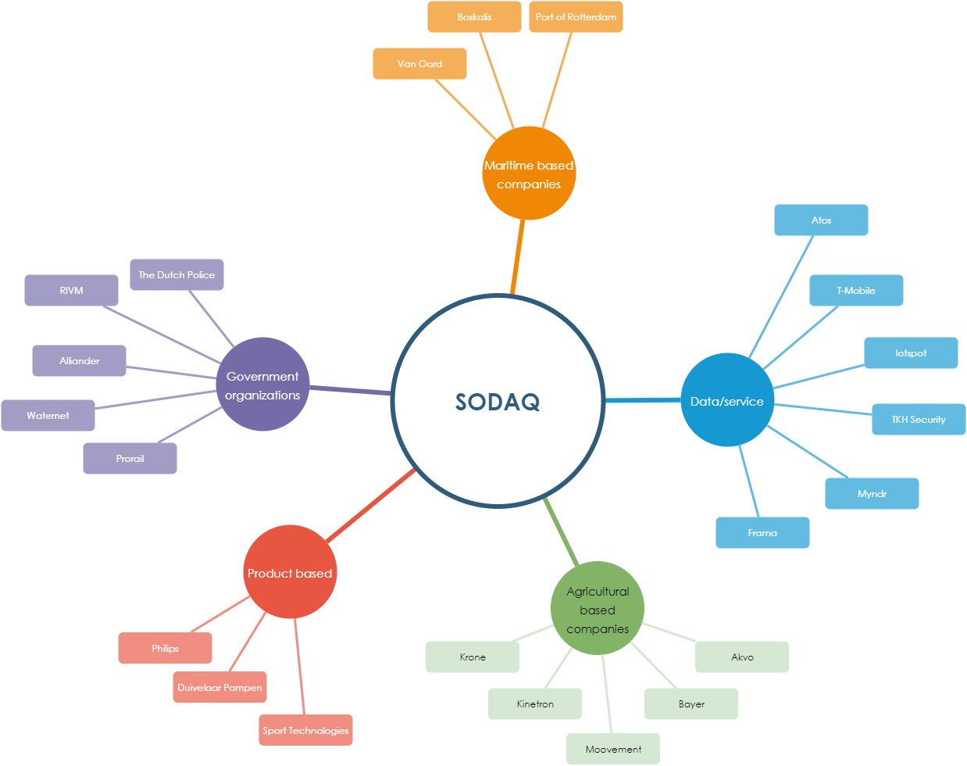

Figure 1 Customers SODAQ grouped

**Data/service**

Let’s start with the biggest branch, SODAQ has several data/service oriented based companies as customer. These do not necessarily produce products but offer their knowledge or services to deliver their goods. These companies will be shortly expanded upon in this text.

Atos is into information/communication-based development such as digital transformation for connected manufacturing (Atos, 2020). T-Mobile is a fairly well-known telecommunications provider that is most likely also interested into knew development for future services.

Iotspot is a company that focusses on tracking/tracing of employees via software & hardware. Their goal is to optimize workplaces by gathering data from workplaces to make them as agile as possible (Iotspot, 2020). TKH security offers smart solutions on a wide spectrum: care/cure, government, office/retail, parking, telecom, data/energy and infrastructure. These can range from video management towards a parking guiding system (TKH Security, 2020). Myndr is a company that delivers software filters for in homes and schools. These allow parents/teachers to restrict the allowed websites for children. These restrictions come in different shapes and sizes and allow for either learning or pastime activities (Myndr, 2020). Lastly there is Frama this company handles packages/post & e-mails for small to middle sized companies (Frama, 2020).

**Agriculturally based companies**

These companies have based their products/services to be suited for the agricultural market. Starting with Krone for example, this company invest in self driving mowers and digital systems to be as optimized as possible (Krone, 2020).

Kinetron does not entirely focus on agriculture, but it has an irrigation-based part to make smart grid irrigation possible. They do this via smart valves and controllers for the irrigation network (Kinetron, 2020). The company Moovement however is more agriculturally based, this company focusses on tracking cattle and optimizing its management (Never lose your cattle, 2020).

The company Bayer is more well known, with its focus on the agricultural market. This company is however also expanding its capabilities into the digital market with smart tools to better the performance of farmers (Bayer, 2020). Lastly for this section there is the company Akvo this company also focusses on data gathering/optimalisation with a focus towards smallholder farming. It is even possible for them to test the quality of water with a smartphone, which can help small farmers (Akvo, 2020).

**Product based**

This involves 3 companies that have built their focus towards delivering products. Philips for example is a well-known company that has a wide area of products available. It is therefore no surprise that they are a customer of SODAQ since Philips itself always seems to be looking into new market segments such as smart solutions (Philips, 2020). Next is Duivelaar Pompen, this company sells different kind of pumps, including pumps for drinking water, process water, sewage water and sprinkler installations. They also offer maintenance services and with that it is no surprise that they would be interested in smart solutions, since monitoring of these pumps can be quite important (Dp, 2020). Lastly there is Sport Solutions, this company develops/manufactures different types of LED lighting for various types of playing fields (Sport Technologies, 2020).

**Government organizations**

SODAQ also has several government organizations as clients. This involves the Dutch police force. The police have an innovation lab where they work with organizations and such on different kinds of innovative ideas. One of these solutions involves sensors and smart camaras (Politie, 2020). SODAQ also works with the Rijksinstituut voor Volksgezondheid en Milieu (RIVM) this organization focusses on the health of the citizens and environmental aspects.

As for Alliander, Waternet & Prorail these are all owned by the Dutch government as well. Alliander is an energy company that also maintains infrastructure, they do this for gas and electricity (Alliander, 2020). Waternet focusses on drink water supply, sewage and water management. They work for the municipality of Amsterdam water authority Amstel, Gooi & Vecht (Wat is waterbeheer?, 2020). As for Prorail its shares are owned by the government via Railinfratrust. This organization plays a big role in infrastructure management for the Dutch railroad system (Organisatie, 2020). These 3 companies do however have several things in common which is most likely the reason for them being a customer of SODAQ, this is gaining more inside into their processes.

**Maritime based services**

Lastly SODAQ has several clients focussed on the maritime industry. Starting with Van Oord this company focusses on dredging and land infrastructure in the Netherlands. They also focus on offshore infrastructure for wind, oil & gas however. Their solutions are focussed on innovative and sustainable ideas which means that data gathering and timely adjustment of certain processes are most likely welcome (Van Oord, 2020).

Boskalis an dredging focussed company which puts a big emphasis on developing cutting-edge technology to optimize their processes including environmental sustainability (Boskalis, 2020). Lastly there is the Port of Rotterdam, they oversee all the processes happening in the harbour which would explain their interest in smart solutions to optimizes their processes since it is one of the busiest ports in the world (INNOVATE. ACCELERATE. MAKE IT HAPPEN., 2020).

## Project scope

Based on the earlier made Project Initiation Document (PID) and the problem definition the following points still form the scope:

* The mesh network will be made based on existing protocols and will not be built from scratch
* The project will be executed within the span of 20 weeks
* The project is limited because of the measures against the COVID-19 virus

The first point of the scope clarifies that the network will not be made from scratch. This is because there is a lot of information about LoRa mesh protocols available. To build a new protocol from scratch takes a lot of time and is not necessary for this project since the existing protocols suffice the needs of the project owner.

The second point of the scope clarifies the time span of the project. The time span for this project consists of 20 weeks given by the HU. In case the project is not finished within 20 weeks, SODAQ can decide what happens to the project in the future. They can either decide to use the information from this project in their existing projects, or the project can be continued by a different team.

Lastly the scope clarifies that the project is limited by the measures against the COVID-19 virus, which means most meetings will be done via an online videocall service and the students have to make do with the equipment they have at their homes.

## Results and deliverables

This report/research is built around the main research question:

*“How can a synchronous power-state LoRa mesh network be realised for SODAQ applications?”*

This means that within the time span of the project until January 2021 to realise the LoRa mesh network. The research group is working on this assignment as per instructed by SODAQ to research and develop a LoRa mesh network with the intent of keeping the power consumption of the network as low as possible.

The project group needs to research how to set up their own LoRa mesh network and compare which hardware components and LoRa mesh protocols are best suitable for a low power wide area network (LPWAN). This also includes the need to simulate the network to establish its parameters. This needs to be done in combination with determining the possible applications for a low power LoRa mesh network.

In order to show all the questions that need to be answered and will be shown in Table 1. These steps need to be completed in order to provide a complete research report.

Table 1 Research questions

|  |  |  |  |  |
| --- | --- | --- | --- | --- |
|  | | Reason/Goal | Approach | Changes made during the project |
| Main question | |  |  |  |
| How can a synchronous power-state LoRa mesh network be realised for SODAQ applications? | | To be able to facilitate lower user-costs for LoRa applications there is a need for a LoRa mesh network which can be implemented to improve various products and applications made by SODAQ. The goal is to develop a network as a proof of concept while only impacting the low power nature of the technology minimally. | By executing this product using an established project structure the main question will be answered in separate parts. In doing so the main question is divided up between separate research questions which are listed below. | Due to certain unforeseen external and internal factors the projects content has changed from the initial project documentation. This column will be used to explain where and when alterations where made. Some questions from the original set were removed due to their overlap with others or the inability to answer them within the current scope. |
| Research questions | |  |  |  |
| 1 | Which applications are considered viable for LoRa mesh in a commercial setting? | To further specify which aspects should be taken into consideration while designing the system one should know which factors are considered valuable by the end users and which factors are commonly seen in SODAQ’s product line-up. The goal is to evaluate and validate the design criteria using product and market analysis. | Research shall be conducted to assess the value of the application of a LoRa mesh by assessing the possible added value on the current product line-up. | This question’s definition of done was changed from the 3 customer persona’s required to a more reasonable analytical approach. The customer persona’s were provided regardless but serve a lesser purpose in answering this question in the interest of a wider more informative scope. |
| 2 | What parameters need to be determined to develop a LoRa mesh network? | The working of a LoRa mesh network will be dependent on various parameters. It needs to be clear which parameters need to be used. The values of these parameters can then be determined using a simulation. | Desk research will be conducted on LoRa parameters. | No changes where made to this question. |
| 3 | Which regulations, legislation and external factors influence the application of LoRa mesh? | There are certain rules and regulations regarding the use of LoRa and several external factors. The goal is to find out which of these should be taken into consideration while developing a mesh network. | Desk research will be conducted on the influence of local and foreign legislation on the use of the network. | No changes where made to this question. |
| 4 | Which existing LoRa mesh protocols are available and which one is best suited to the application, based on power consumption and reliability? | There are different protocols for LoRa mesh. For the application it is important that the module uses as little amount of power as possible. To achieve this goal, it is important to research the different protocols for their advantages and disadvantages. | Desk research on different Mesh protocols. Using pros and cons a protocol will be chosen. | No changes where made to this question. |
| 5 | Which method is best suitable for keeping individual nodes synchronized? | In order to avoid data collision, the nodes need to avoid sending data simultaneously. For this reason, they need to be synchronised. | Research will be done on methods to synchronise the nodes. | This question became less relevant as the scope of the project tightened, therefore the demand from the definition of done have been foregone to enable a more project-oriented answer. Due to the decreased relevance the size of this questions scope was reduced independently from the scope, it has however been answered appropriately. |
| 6 | What are the limitations of the LoRa mesh? | The implementation of a mesh structure comes with limitations. The answer to this question will give insight into these limitations and show if it will improve or deteriorate SODAQ’s applications. | Simulation will be done using the parameters from research question 2 to determine to the limitations. | Due to the scope of this project this question could not be answered without significant additional time and testing, therefore it has been answered with logical reasoning instead of the proposed testing. The results are no less credible but are less detailed than originally proposed. |
| 7 | In which way could a LoRa mesh simulation be realized? | In order to further develop and explain the simulation(deliverable) a research question was created with the goal of covering this subject. | All separate components which make up the proposed LoRa mesh system will be tested through the simulation if possible. | This question was added as a way to document the research done into the simulation. Its answer is necessary to answer the main question and has therefore been instated as a research question. |

## 

## Potential customers

Customer personas were made to gain certain insights into the possible customers for the fire prevention system, see paragraph 3.1. These canvases generally help to gain grip on who the customer is and the benefits that they may receive from the product.

Each persona canvas always begins with a name and role, this is done to anchor the persona into reality. The middle of the canvas consists of the customer needs, this can help identify what they want to gain from the product.

The left side of the canvas contains the negative parts. The negative trends focus on environmental trends and life experiences. Headaches are caused by professional/private issues. Fears focus on what kind of fears the persona might have in the future.

The right-side concentrates on the more positive aspects. The positive trends meet the optimistic developments in the persons live. The opportunities focus on the positive persona experiences in the persona’s work/private life. Their hopes focus on positive experiences that the persona’s might have in the future, this goes for work/private life (Design a Better Business, 2020).

**Centraal Beheer Achmea**

This persona is based on a conversation with one of the business advisors of Centraal Beheer Achmea, see attachment 1 (Dijk Van, 2020) and Table 6. Centraal Beheer Achmea is a big insurance company based in the Netherlands and is known for its famous slogan of “even Apeldoorn bellen”.

The need for this persona is to provide more insurances. The LoRa mesh fire protection system provide a possible solution. As for the current outward negative trends empty office buildings are not being insured against fire. This leads to headaches with the increase in empty office buildings that are not being insured.

The organisation itself is currently busy with a big internal reorganization, which makes it harder to make time to invest into new ideas like this. Not insuring these buildings could lead to miss in revenue, this was not part of the conversation but would be a logical consequence.

As in terms of positive trends LoRa mesh could form a cheap alternative to provide as a minimal safety feature in order to insure empty buildings or help homeowners with cheap and effective fire protection.

This also provides the opportunity to be one of the first companies to offer this kind of insurance for empty buildings and such. It is even possible that homeowners could benefit from this as well. This could hold the potential to gain more revenue by gaining more customers. The hopes for the future would lie into the proper development of a cheap/effective fire detection system so that it can be incorporated into insurance packages of the company.

**Office owner**

This persona is based around a person who currently has an empty office to maintain, because of the current climate Table 7. What Bob needs is to be insured against fire as under the current circumstances he is not insured against such damage (Dijk Van, 2020).

This leads him to worry greatly about his property that is not insured, however maintaining an elaborate fire prevention system proves to be quite expensive especially with all the other costs that have to be maintained. This still does not suppress his fear of losing his property in a fire without any way of compensation.

This does offer the positive trend of the cheap LoRa mesh fire protection system that could function as a solution for this. With a small investment it could be possible to detect fires early and possibly make the building viable for insurance as well. This allows for Bob to ease his worries in the event that his building catches fire. Bob hopes that the development of the systems progresses fast so that the building is viable for insurances as fast as possible.

## Strategic importance

The strategic importance of this project for SODAQ is based mainly on the individual answers provided by the research questions, the expectation is that while interesting the developed simulation is not directly useful to SODAQ. The use case provided will most probably not be implemented by SODAQ. The value of the deliverables is where the current project delivers its boon to SODAQ, the simulation can be used to investigate the viability of a variety of different setups, enabling SODAQ to simulate the use of LoRa mesh for proposed projects. Thus opening up opportunities for acquiring new customers by expanding the technological capabilities of the product line-up.

# Analyses & diagnoses

This chapter and its paragraphs are based on the on the research questions and its deliverables. Paragraph 3.1 discusses the possible commercial applications. Paragraph 3.2 contains the research of the parameters for the simulation. Paragraph 3.4 discusses several protocols for LoRa mesh. The most suitable synchronization method is discussed in paragraph 3.5. Paragraph 3.6 considers the limitation of the LoRa mesh network. Finally in paragraph 3.8 contains the conclusion of this chapter.

## Possible applications for a viable for LoRa mesh in a commercial setting

To chart out commercial applications for the LoRa mesh network several points of view where considered. Unfortunately, they have all turned out to be non-applicable. Since the main focus point of LoRa mesh is to create an extension via the mesh network without using extra gates.

Several cases were discussed with the project group:

* Waste management
* Water management
* Saving the rain forests
* Fire prevention system

Any applications for this kind of network within the Dutch market are not viable. This is because LoRa already has a 100% coverage rate within the Netherlands (KPN, 2020). So as to any applications towards a wider network of nodes connected on containers for waste management would not be viable, since it is possible to connect them straight towards the gateway. This saves power consumption, because the nodes would only need to send their data towards the gate and not towards one another.

There also seem to be multiple programs on the way to ensure more coverage worldwide in terms of LoRa (LoRa Alliance, 2020). As well as other initiatives that provide services towards LTE-M & NB-IoT that are being rolled out around the globe. This goes for SIXFOX as well (sigfox, 2020).

As for the possible rainforests option, this option was suggested by Alessandro Verdiesen. By using a series of nodes attached to trees. The idea was to have these nodes register higher temperatures or if the tree that it is on is falling down. With this data it could then be determined if there would be deforestation or not.

After some preliminary research it turned out that there are already several companies providing different kinds of solutions on a local level. The most interesting one being Rainforest Connection. This company uses solar powered mobile phones with powerful microphones to create a live feed around the globe. This data is automatically analysed for chainsaws/fires and allows local communities to respond towards deforestation (Rainforest Connection, 2020). The organization even has an app where they livestream the recordings.

**Fire prevention system**

After a lot of deliberation and brainstorming sessions within the group, 2 possible applications where reached. The first one was to use LoRa mesh for pipelines where it is rather difficult to implement a functional LoRa network. This has already been determined to be viable in very specific user cases (Huh & Kim Yeol, 2019). This however would limit the usage to a very specific user case. Therefore, it was suggested to make a low power fire detection system for empty office buildings, where the Mesh part would serve as a backup when one of the nodes cannot reach the gates.

For office buildings a declaration of usage must be given when 50 or more people are working there, or when certain situations apply depending on the industry (Rijksoverheid, 2012). This with the type of industry and other conditions determine the level of fire prevention methods needed. This means that for empty office buildings no fire prevention methods are needed. Table 2 showcases the percentage of empty buildings in the Netherlands.

Table 2 Empty buildings in the Netherlands



(Centraal Bureau voor de Statistiek, 2019)

As of 2019 6,3% of the offices in the Netherlands where not used, this translates to over 3,3 million square kilometres. This number will mostly likely increase when the statistics of 2020 are published due to the corona crisis. As for the shops there would be around 2,6 million square kilometres that is not in active usage.

As discussed with a Senior Account manager of Centraal Beheer Achmea these types of buildings and the homes of regular homeowners could potentially be viable for this type of fire prevention. This could prove interesting for integrating it into their insurance packages and with that provide a potential steady market share. These types of companies would basically sell the product on their own if they would be integrated into their services.

## Necessary parameters to develop a LoRa mesh network

To ensure an efficient and reliable communication LPWAN devices often provide a large number of transmission parameters. A LoRa device can for example be configured to use different spreading factors, bandwidth settings, coding rates and transmission power, resulting in over 6720 possible settings (Bor & Roeding, 2017).

It is difficult to find the right settings that will keep the transmission energy cost to a minimum while also maintaining the required communication performance.

There are five settings that can be changed on a LoRa device to tune link performance and energy consumption:

* **Transmission power (TP)**
  + The TP on a SX1276 LoRa radio can be set from -4 dBm to 20 dBm, in 1 dBm steps, but because of hardware implementation limits, the range is often limited from 2 dBm to 20 dBm. The TP range is different depending on the transceiver sort. Also because of hardware limitations, power levels higher than 17 dBm can only be used on a 1% duty cycle.
* **Carrier Frequency (CF)**
  + The CF on a SX1276 can be programmed in steps of 61 Hz between 137 MHz 2.4 GHz. Depending on the LoRa chip, the range may be limited. Also, different regions have limitations in respect to the carrier frequency, set by the LoRa Alliance.
* **Spreading factor (SF)**
  + The SF is the ratio between the symbol rate and chirp rate. A higher SF increases the Signal to Noise Ratio (SNR) and thus the sensitivity and range, but also increases the airtime of the packet. The number of chirps is calculated as 2*SF. Each increase in SF halves the transmission rate, doubles transmission duration and ultimately doubles energy consumption. SF can be selected from 6 to 12.
* **Bandwidth (BW)**
  + The BW is the frequency range of the carrier wave. Larger BW gives a higher data rate and thus less time on air, but lower sensitivity (because of integration of additional noise). A lower BW gives a higher sensitivity, but lower data rate. Data is sent out at a chirp rate equal to the bandwidth; a bandwidth of 125 kHz corresponds to a chirp rate of 125 kbps. The bandwidth can be selected in a range of 7.8 kHz to 500 kHz, but LoRa devices typically operate at either 500 kHz, 250 kHz or 125 kHz.
* **Coding Rate (CR)**
  + The CR is the Forward Error Correction (FEC) rate used by the LoRa modem, it protects against bursts of interference, and can be set to either 4/5, 4/6, 4/7 or 4/8. Higher CR offers more protection but increases time on air. Devices with a different CR can still communicate with each other if they use an explicit header, this is because the CR of the payload is stored in the header of the packet, which is always encoded at CR 4/8.

With a mesh network there are a few other factors in play that also have an impact on the reliability of connection and power consumption. One of these factors is data collision, this occurs when two or more devices try to transmit using the same data rate, frequency and power. The more nodes in the area, the more collision sensitive the network will be. (Rahmadhani & Kuipers, z.d.) have shown 5 cases in which frame loss may occur within a LoRaWAN network.

Another factor is how the different devices are going to be communicating with each other. The simulation will create connections between nodes based on the LoRaBlink protocol, more on this subject in chapter 3.43.7. The parameters in the simulation will be limited to the limitations set by the LoRa-Alliance for the EU 863-870MHz ISM band (LoRa-Alliance, 2015). This means that among other things the bandwidth 500 kHz cannot be used and in the bandwidth 250 kHz only a spreading factor of 7 can be used, also a maximum packet size is defined by the spreading factor and bandwidth. Limitations are documented in the code of the simulation.

## Regulations, legislation and external factors that influence the application of LoRa mesh

In order to answer this matter properly, research has been done in regard to legislation and external factors. Most of the necessary information was provided by an organisation called LoRa Alliance, LoRa alliance is a non-profit entity with the goal of further defining the LoRa standard and sharing experiences between exploiters of the technology (LoRa-Alliance, 2020).

The information on local legislation provided by LoRa alliance has been verified by use of the local documents for the stated regions. Returning to the question at hand, the influence of legislation and external factors have been researched and compared per region, the following insights have been obtained in this manner.

### General legislation

The general standard or ruleset for LoRa seems to dictate the following variables (with some regional exceptions):

* LoRa modulation shall be used.
* The duty cycle shall remain below 1%
* Frequency bandwidth will be 125kHz
* Spreading factors fall between 7 and 12

These values are generally heeded as the absolute baseline, though some exceptions are made in local regulations and standards. The duty cycle that is stipulated demands that for every second you transmit the node should remain silent for the following 99 seconds. This is non optional and is a general rule across all LoRa standards.

### Legislative regions

When researching the restrictions laid down by the various institutes and standardisation organisations it became apparent that there are multiple blocks of countries which use the same standards, these standards are all covered in the “RP002-1.0.1 LoRaWAN Regional Parameters” document is provided by LoRa-Alliance (LoRa-Alliance, 2020). The major legislative regions are defined as follows:

* European Union
* United States of America
* Peoples republic of China
* Commonwealth of Australia
* Republic of Korea (South Korea)
* Russian Federation

These regions do not cover the entire planet, notably the continent of Africa is fairly undeveloped in terms of their own legislation on LoRa/LoRaWAN networking (The things Network, 2020). The southern part of Africa appears to use European guidelines where the northern part of the continent does either not enforce regulation or abides by a standard of choice. It has been chosen to omit the north African regions from this analysis because the absence of consistent regulations.

The Chinese restrict the use of their LoRa bands to specific purposes, mainly civil metering, it is not possible for external parties to operate within the supported bands on Chinese soil without explicit permission from the Chinese government. This process makes operating in china unfavourable due to the long and arduous process required to get permission, this is why China will also be omitted from the analysis as it would not produce information of any value.

### Legislation between regions

The regions as defined above differ in certain ways, mainly on the used frequency bands. As the impact of these differences is negligible when considering their effects on practical applications no further use is made of this information. A spreadsheet containing all the standards and their differences is displayed in Attachment 5 Different legislation regions.

### The differences between regions

The standards as defined above differ in certain interesting ways, the more notable ones are as follows:

* All countries except for Russia and Japan operate three frequency bands where the former operate 2.
* China and Korea do not enforce specific duty cycles, where other regions do tend to attach value to the <1% of the general LoRa standard.
* Korea specifies a maximum EIRP instead of the duty cycle.

These differences do not exert a notable influence on the success of the LoRa mesh project as all of the important values are covered in the base standard. The legal restrictions on purpose imposed by the Chinese government do not significantly impact the project either because of the yet to be determined purpose of the mesh, it should however be taken into consideration while developing a product using the LoRa mesh.

### Other general external factors to be considered

Other variables that might influence the use LoRa mesh are Weather and location. Both weather and location play important roles in the field situation when working with LoRa, both will be explored below.

#### Weather

The weather can have a pronounced impact on the range of transmissions and the ability to reliably transfer information. The weather factors that have been recognised to have an impact on signal strength are general humidity, wind speed and direction, temperature and air pressure. This was constituted in a research paper written by Joseph Amajama where the following correlations were found and proven (Amajama, 2016):

*“Increase in atmospheric temperature results in the degradation of signal strength, observing other weather components constant. The correlation between the signal strength and atmospheric temperature was found to be r = -0.94.”*

“*More so, increase in relative humidity affects the signal strength negatively. In other words, signal strength is inversely proportional to relative humidity, provided that other weather components are observed constant, here r =-0.93.”*

“*And, the atmospheric pressure impacts negatively on signal strength provided that other weather parameters are observed constant and the correlation between them is r = -0.99.”*

Thus, it can be stated that this factor is important to take into account when deciding on the location to use the LoRa mesh. As weather circumstances can vary significantly on a day-to-day basis, and are by definition relatively unpredictable, only the most global patterns serve as valuable selection criteria.

Using LoRa mesh in an especially humid environment for example will have a relatively predictable negative effect on its range. On the other hand, when used near the sea and transmitting inland it can be observed to increase range substantially, however this is of lesser importance because the phenomena cannot be counted on to produce this result reliably.

#### Terrain

Another influencing external factor on the use of LoRa and by extension LoRa mesh is terrain, terrain influences signal range and strength based on differing amounts of physical obstructions. Differences in the height and surface of the terrain may interfere with the transmissions. The impact of these factors are not exhaustively documented, important correlations have been proven by Oana Lova from Trento university in Italy (Lova, 2017).

While more specific studies have been conducted, none were purposefully relevant to the SODAQ LoRa mesh project and thus Miss Lova’s research remains the main source. The paper concludes by saying that moving out of the smart city environment significantly reduces signal reliability and range.

## Existing LoRa mesh protocols for the simulation

This research topic is based on sub-question 5, the goal of this chapter is to research protocols. In sub-paragraph 3.4.1 will be explained what a protocol is and what the characteristics of an ideal protocol look like. In paragraph 3.4.2 three protocols will be researched to the characteristics of the proposed ideal protocol. The final conclusion of the preferred network can be found in paragraph 3.5.

### Protocol

A protocol is a set of rules that determine how data is sent between the nodes in a network. The protocol defines how the network is set up, how the nodes are synchronised and how the nodes communicate with one another.

To decide which protocol benefits the mesh network the most, the protocols will be compared to an ideal protocol. Based on the requirements and restrictions form chapter 4, the characteristics of the ideal mesh protocol are as followed:

1. Source code criteria: The source code of the protocol is available from open-source websites such as GitHub.
2. Information criteria: Information and documentation about the protocol is available, so enough information is known to compare the protocol.
3. Synchronisation criteria: The protocol synchronises the nodes, so that the nodes are aware when they can transmit their data or are needed to receive data from other nodes.
4. Protocol criteria: The protocol does not waste any battery life by sending redundant information. The protocol will be evaluated on how many messages it takes to set up the network and transfer the data from nodes.
5. Reliability criteria: The reliability of the protocol is as high as possible, so the nodes do not need to retransmit their messages.

### Mesh protocols

This paragraph will feature the researched protocols. The protocols will first be shortly described, then the characteristics of the protocols will be substantiated.

**TSCH-over-LoRa**

TSCH-over-LoRa is a combination of TSCH and LoRa, where TSCH (Time Slotted Channel Hopping) is used for their reliability on wireless communication and LoRa for their long-range capabilities. Both technologies specialise on low power consumption, compared with their alternative technologies like RC-MAC or SigFox.

Documentation available about the TSCH-over-LoRa protocol is scarce. The information about how the TSCH-over-LoRa protocol sets up the network or how exactly the data is transferred from the nodes is not available by the consulted sources. Therefore, an estimation about the redundancy of the messages is not possible.

The synchronisation of the network is done using a beacon. The gateway sends a beacon message on a regular interval. Normally for TSCH a beacon message is sent every 12 seconds. But due to the constrictions of LoRa’s duty cycle, the beacon message is sent every 30 to 40 seconds. Furthermore, the nodes also synchronise whenever they receive an acknowledgement form their parent node. In conclusion, the nodes are synchronised with their parent node every time they send a message and synchronised with the gateway every 30 to 40 seconds.

In one experiment with one gateway and 2 nodes, shows that with most message protocols a reliability near the 100% is possible (Martin Haubro, 2020). However, do be aware that this is with a network with only 2 nodes. If the number of nodes increases, then the reliability will most likely decrease. This is because if there are more nodes, there is a bigger chance they will transmit a packet at the same point in time, resulting in collision between the packets. Unfortunately, there is no data to be found about the reliability with a larger network.

Finally, the source code for the TSCH-over-LoRa is available on GitHub. So, testing and experimentation could be possible, if deemed necessary.

**LoRaBlink**

LoRaBlink is a simple but effective mesh protocol with a relatively simple way of creating a mesh network, but its simpleness leaves way for improvements.

The LoRaBlink protocol sets up their network using a beacon. The gateway sends out a beacon message to every device in its range. The nodes then receive the beacon message and send their own beacon message to every device in it range. The gateway then uses the beacon from the nodes as a confirmation and adds the node(s) to the network. Nodes that receive the beacon message from the nodes and are not already in the network now send their own beacon message to every device in their range and then listen for replies. This continues until every node is in the network. The protocol needs to send only one message per node to set up their whole network.

For the data collection, the protocol only needs one message per node to transfer the data from the nodes to the gateway. The nodes use the beacon message to know from which node(s) they can expect data from (child-nodes) and to which node(s) they can send their data to (parent-node). When a node sends out their beacon message and does not receive a reply from any node, then it knows that it is the last node from the branch and starts sending its data to its parent-node. When a node did get a reply from its beacon message, then it waits until it receives the data from every child-node. Once it got all the data from its child-nodes, it starts sending its and their data to the parent-node.

The LoRaBlink protocol synchronises the network whenever it sends a beacon message from the gateway. The synchronisation is done within the beacon message and the beacon message is send every epoch. At the start of an epoch the protocol starts with the synchronisation of the nodes and ends when all of the data has been collected from the nodes. In the documentation about the LoRaBlink protocol the epoch was set on 5 minutes, so that value is set for comparing the protocol (Martin Bor, 2015), an example of an epoch can be seen in Figure 2.

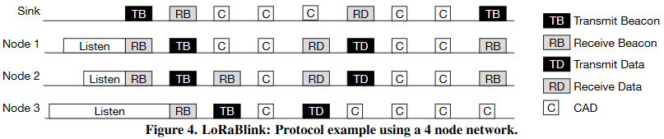

Figure 2: LoRaBlink protocol communication example with 4 nodes

In the same documentation (Martin Bor, 2015), it is stated that the success-rate of messages is about 80% due to collisions in the network. The network contained 5 nodes plus a gateway. The document stated that the LoRaBlink protocol works well in small networks, but with larger networks the chance of collisions increases and so decreases the success-rate.

**PM-LoRa**

PM-LoRa is a mesh protocol based on the LoRaBlink protocol, but PM-LoRa has improvements on the reliability compared with LoRaBlink. PM-LoRa takes more time and energy building its network but makes the network robust and capable of handling more nodes than LoRaBlink can.

PM-LoRa starts with building its network by letting the gateway sent an ‘INIT’ message to every device in its range. Next a node that received the INIT message will sent a ‘JOIN’ message, asking the gateway to join the network. The gateway then receives a join message from the node and sends a CON message back to the node, confirming that the node is added to the network. Finally, the node sends a ADV message to every device in its range, functioning as an INIT message for nodes that have not joined the network. After sending a ADV message, the node can expect a JOIN message from nearby nodes and sends a CON message back. This process repeats until every node is added to the network. The protocol needs to send 4 messages back and forth to add a node to the network. So, every time the protocol needs to create a network, the messages needed to create the network equals 4x the number of nodes.

PM-LoRa uses the same method as LoRaBlink for the collection of data. So, the protocol only needs to send one message per node for the collection of data.

Unlike LoRaBlink, the PM-LoRa does not send a beacon every epoch but keeps the network that it created. LoRaBlink uses that beacon for time synchronisation among nodes. Instead, PM-LoRa uses a DTP (Downward Transmission Period) to send a message to every node in the network. With that message the nodes will be kept synchronised to the gateway. A DTP happens whenever the gateway received all of the data from nodes. So, its frequency depends on the number of nodes in the network. Unfortunately, the documentation does not provide any means on calculating the frequency, so the synchronisation cannot be compared with the other protocols.

In an experiment done by the University of Ulsan (Mai Dinh Loc, 2019), 14 nodes are spread out over an area of 700 by 1000 meters. Using the PM-LoRa protocol, the reliability of the network resulted in a success-rate of 97,6%. PM-LoRa achieves such a success-rate using a Message Collision Avoidance Mechanism. With the mechanism the nodes set up a preamble before they send a message. The preamble has a random length, so the nodes start sending their message after a random interval. When a node is busy with its preamble, it also listens for messages from other nodes. When it hears a node is sending a message, then the node stops its preamble and waits for the next opportunity to send a message. This avoids that two nodes are transmitting at the same time and so reduces the chance of collision.

Unfortunately, the available information about the PM-LoRa protocol is very limited. So is a detailed documentation about the source code was not available. An attempt was made to contact the author of the original article, but so far the author has not replied.

## The most suitable method for keeping individual nodes synchronized

In order to get a standard LoRa mesh network working a sleep mode for the nodes is not necessary. The issue with non-synchronous LoRa mesh is that it consumes more power in comparison to a LoRa mesh network with nodes that can go into sleep mode. Therefore, the goal is to design synchronous LoRa mesh. Synchronous means that every node will only go into an active state periodically when it is time to send or receive messages. For this a RTC (Real-Time Clock) will have to be used (Ali, 2020).

Quartz clocks are the most used RTC’s in most small, battery powered devices. These clocks can keep time with an error margin of around 2 seconds a day depending on environment variables. The error margin can be fixed by synchronising the clock’s time with other nodes through LoRa messages when the device is active. This way the clock will retain the correct synchronisation timing (Lombardi, 2008).

Another way to fix the clocks error margin within the LoRa mesh nodes is with a GPS (Global Positioning System) module. GPS packets contain a time stamp, which can be used to set the correct time for every node. Using GPS will require more power than using LoRa messages to synchronize but using LoRa to synchronise will limit the maximum amount of data the system can handle (Gakstatter, 2015).

The decision whether a quartz clock, GPS or a different method will be used depends on the device that it will be used in.

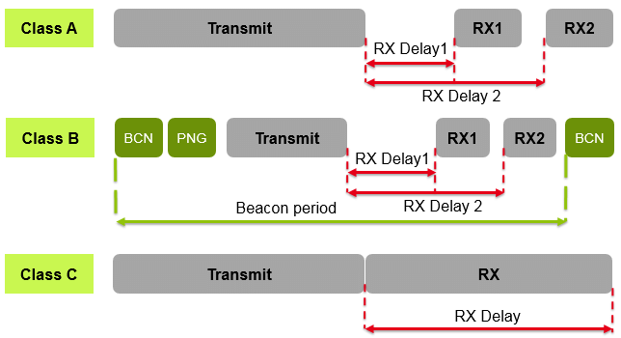

Figure 3 The 3 different LoRa classes.

There are 3 classes of LoRa Devices.

Normally for a synchronous Mesh network a class B LoRa module should be used, this type only receives and transmits at specific times. The use case of a fire prevention system would ideally require a class C LoRa module. A class C LoRa module can receive messages at any time. This means that fire warning messages can be sent at any time. Class B modules in a Mesh network can only send data once every few minutes, which is not optimal for the reliability of the fire prevention system. The fact that a class C LoRa module would be optimal to be used also means that the use case does not make use of a Synchronous LoRa mesh network (Techplayon, 2007).

## Limitations of the LoRa mesh network

The implementation of a mesh structure comes with limitations, these need to be explored and defined to assure proper use and development of LoRa mesh. The answer to this question will give insight into these limitations.

The use of LoRa mesh provides certain niche benefits, these benefits however, come at a cost. The factors which limit the use of LoRa mesh from a technical standpoint can be divided into the following categories:

* Power drain
* Data Rate
* Internal interference
* Cost effectiveness

These categories will be elaborated upon below, where their influence and comparative limitations will be outlined.

### Power drain

Due to the nature of Mesh networks, there are added complications to the communications.

An issue with a LoRa mesh network is that certain nodes that are close to the gateway will have to forward all the packages from nodes that are not in range. This will require a lot of power from these nodes. In order to save power alternative message forwarding paths could be used to spread out power consumption.

To get an idea of the power drain of a node in a mesh network, 8 different experiments are setup. These experiments take the extremes in terms of spreading factor and transmit power. Each experiment is done with different amounts of traffic. Traffic is defined as how many nodes a node must forward messages for.

The expectation is that the nodes that have traffic, have a significantly faster drained battery. A trade-off can be made with the results of the experiments to see if a maximum hop limit would help with a lower power drain. A period time of 5 minutes according to the LoRaBlink protocol is used for the first 4 experiments.

In each experiment the send until empty button is used to see which node runs out of battery first. Each experiment will be done 10 times, each time a node is added in connection to the node closest to the gateway. This way it is possible to see what kind of impact it has on the battery when a node must forward messages from 0 to 9 other nodes (traffic). When a node has a traffic of 0, it basically mimics a LoRaWAN network. This is because the node is then directly connected to the gateway. By getting these results from the simulation a comparison can be made between a LoRaWAN network and a LoRa mesh network. For each experiment, the number of sent/received packets and the time to live of the node was on for are recorded in an excel sheet. The experiment parameters are as follows:

Table 3: Simulation experiments with extremes parameters.

|  |  |  |  |  |  |  |  |  |
| --- | --- | --- | --- | --- | --- | --- | --- | --- |
| Experiment | Number of nodes | TX power  (dBm) | Spreading factor | | Battery capacity (mAh) | | Payload  (bytes) | Period  (minutes) |
| 1 | 20 | 14 | | 12 | | 1000 | 100 | 5 |
| 2 | 20 | -2 | | 12 | | 1000 | 100 | 5 |
| 3 | 20 | 14 | | 7 | | 1000 | 100 | 5 |
| 4 | 20 | -2 | | 7 | | 1000 | 100 | 5 |
| 5 | 20 | 14 | | 12 | | 1000 | 100 | 0 |
| 6 | 20 | -2 | | 12 | | 1000 | 100 | 0 |
| 7 | 20 | 14 | | 7 | | 1000 | 100 | 0 |
| 8 | 20 | -2 | | 7 | | 1000 | 100 | 0 |

In experiment 1 & 2 it’s possible to see the power drainage with the highest spreading factor. This means it has the longest range, but also the longest time on air and thus the highest power drain in theory. Difference between the 2 experiments is the transmit power with which packets will be sent. The maximum of 14 dBm is used to see the maximum power drainage and the minimum of -2 dBm to see the minimum power drainage.

Experiment 3 & 4 is set up the same way as 1 & 2, with the only difference being the spreading factor. The lowest spreading factor 7 is used which has the shortest range, but also the shortest time on air. With this spreading factor a node will be able to send a lot more packets.

These four experiments are then repeated, only this time no period is defined. This causes the nodes to have a significantly longer time to live.

The results of the experiments are documented and discussed in chapter 5.5.

### Data rate

The data rate for LoRa mesh can be a limiting factor. Normally when a LoRa module needs extra range, a higher spreading factor is used. The issue with this is that with the use of a higher spreading factor the data rate goes down.

If the goal is to extend range, a spreading factor of 12 should be used to ensure a long-range connection. A spreading factor of 12 already has a relatively low data rate compared to other spreading factors. If Mesh is used with a spreading factor of 12 the data rate for the system will be even lower considering that in a mesh structure node have to send and receive more data than a standard point-to-point LoRa network.

### Internal interference

In order to send and receive packages on nodes the same spreading factor and bandwidth will have to be used on every node in the Mesh structure. This is because the receiver on every node can only receive messages that use the same spreading factor and bandwidth as they are set to receive (Rahmadhani & Kuipers, z.d.). The issue that comes with sending a lot of packages at the same time on the same bandwidth and spreading factor is that interference will occur. This means that when the Mesh system is very dense there will be a higher chance of packet loss compared to a lower density setup.

### Not suitable for use with general purpose applications

As stated in the introduction of this paragraph LoRa mesh possesses some niche benefits for certain applications, these benefits include but are not limited to the following:

* Redundancy of the signal
* Added range
* Fewer Blind spots

These benefits however come paired with the use of a full Mesh system. If the Mesh network is not of sufficient size or if it does not utilise the benefits it is often advisable to forego Mesh entirely. As discussed in paragraph 3.3 the commercial viability of a mesh network is severely limited by the proliferation of LoRa devices in the Netherlands which resulted in nationwide coverage of LoRa gateways in the Netherlands (KPN, 2020). This means that in order to be useful the LoRa mesh needs to provide crucial benefits which cannot be compensated for by the use of an extra gateway. For example, reaching the basement floor of a building through a node on the floor above instead of the local gateway. The niche benefits of LoRa mesh in contrast to the general appeal of LoRaWAN make this technology really limited in use.

## Realizing a LoRa mesh simulation

### Python

At the start of the project the simulation consisted of a number of calculations to calculate the time on air and power-consumption per packet transmission. Excel was used to simulate these calculations. As the simulation required more calculations and visualisations, the simulation became too complex to calculate in Excel.

After a meeting with the Lead Software Engineer of SODAQ, it became clear that Excel was not an adequate candidate to simulate a whole mesh network. He suggested that the simulation might be possible in Python, because Python has functions that are capable of handling many calculations and Python has the ability of plotting graphs for the visualisation of a mesh network. There was also some experience of the python language between the students which made python the prime candidate for making the simulation.

### Simulation setup

To make an evaluation of a LoRa mesh network’s performances and see which parameters work best in this topology a simulation is made. Within the simulation there is the ability to adjust certain factors and get a visual representation of the performance of the network. The simulation has the following input arguments:

* Number of nodes to be simulated
* Transmission power of the nodes in dBm
* Spreading factor with which the nodes will be sending packets
* Battery capacity of the nodes
* Payload size of the sent packets in bytes
* Period at which the nodes will be sending a packet in minutes.

If in the simulation there needs to be a defined period at which the nodes send a packet, the period argument can be filled in (this means the nodes act like a class B LoRa device). Say that the period is set at 5 minutes, then every time it sends a message, 5 minutes of sleep mode current (0,2 µA for SX1276) is translated into power drain (0,2 µA * 3,3 V = 0,66 µW). It can also be left on 0 which means the nodes act like a class C device, this means a lot of time listening and so a lot of power drain. Also, when there is no period defined the nodes will send as much and as soon as possible. When doing this the nodes have a longer time on air in a day than is officially allowed.

With these arguments the simulation will be setup. Firstly, a gateway is initialized and placed in the middle of the plot. Secondly, the number of nodes passed as argument will be generated with the given transmission power, a carrier frequency of 868 MHz and a random x and y position.

After the gateway and the nodes are initialized a beacon will be sent by the gateway. A beacon is a packet which contains the number of hops to the gateway. Upon receiving a beacon from the gateway, nodes will send out their own beacon. Nodes that receive this beacon will send another beacon and so on until all nodes have received a beacon or have established that they are not in range of any nodes that sent out a beacon. Using this beacon message, a mesh network with its connections, distances of connections and number of hops to gateway for each node is obtained.

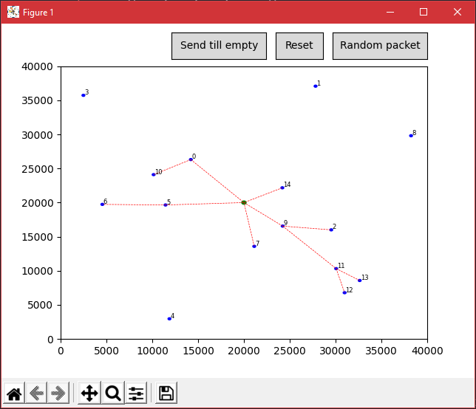

Figure 4: Simulation's mesh network visualization.

A plot of the mesh network is then shown in a new window using the python package matplotlib. The nodes are shown as a blue circle, the gateway as a bigger green circle and connections are shown with a dashed red line. The user of the simulation can reset the nodes and window via a button if the randomly generated setup is not as desired.

If the user wants to see how many messages can be sent in the network, the button “send until empty” can be pressed. This starts a loop of randomly giving nodes packets and sending them to the gateway via other connected nodes if necessary, or directly to the gateway if in reach. The loop is ended when the calculated energy usage of a node is equal or less to its defined battery capacity. Output is printed with information about the node like amount of sent packets, amount of received packets, energy used and lifetime.

### Hardware aspects

The LoRa transceiver used in the simulation is the SX1276. This transceiver is chosen mainly because SODAQ already uses this transceiver in some of their LoRa devices. The simulation is made using the characteristics of the SX1276. This includes its transmission current draw based on the transmission power in dBm and receiving current draw. By using the SX1276, the most accurate representation of the way LoRa mesh could function in SODAQ devices is simulated. Still a comparison of the parameters used in the simulation between two different transceivers is made.

**Semtech SX1276 vs Semtech SX1262 Power consumption**

The SX1276 and SX1262 have relatively even transmitting current when it comes to sending at around +14 dBm, which is the European limit for sending with a spreading factor of 12. If the European transmission signal strength limit is surpassed, the SX1262 has a significant more power efficient transmission than the SX1276.

The sleep current for the SX1276 is on average 0.2 µA and the sleep current of the SX1262 is 0.160 µA. The receive mode current is around the same for both transceivers, however it seems like the SX1262 has more low power options.

The datasheets tables with information about the current draw in different modes for both chips can be found in Attachment 3 Current draw SX1276 & SX1262.

### Mesh networks

The mesh network setup in the simulation is made based on the LoRaBlink protocol, more information on how this works can be found in paragraph 3.4. The basic gist is a sort of message flooding method. This is a method where the gateway sends a so-called beacon message containing the number of hops to the gateway. If a node receives this message it will also send one, until all nodes in range have received a beacon.

In this simulation RSSI is taken in consideration and is dynamically calculated each time a packet is sent. A beacon has a spreading factor of 7, this is the spreading factor where the range is shortest. This is done so that when a connection between nodes or between a node and gateway is made, a packet can always be sent over that connection no matter the spreading factor of the packet.

There is a choice available when setting up the mesh network. Option one is having the connection based on the least number of hops from node to gateway. Option two is having the best RSSI between nodes.

When sending a beacon, a node goes through all nodes, calculates the RSSI between the node (sendNode) sending the beacon and the node its looking at (recNode). If this RSSI is higher than the RX sensitivity (a dBm value at which the LoRa chip is still able to demodulate a signal) it is clear that this recNode is able to receive the beacon. But the fact that the node is able to receive the beacon, does not mean it’s the ideal connection. This is where the choice of option one and two comes in.

When deciding on what connection to make a node goes through the code shown in Figure 5

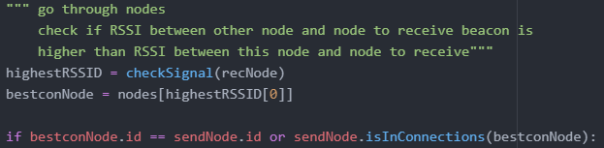

Figure 5: Connection decision node.

After having established that the recNode is able to make a connection, it starts looking at all nodes again via the function checkSignal. This function returns a list of two items, the node id with which the recNode has the best connection to (bestconNode) and the RSSI of this connection. It then first checks if this bestconNode is the sendNode, because if this is the case, the connection should be made. The second check is if the bestconNode is already connected to the sendNode. In this second check the choice mentioned earlier can be made.

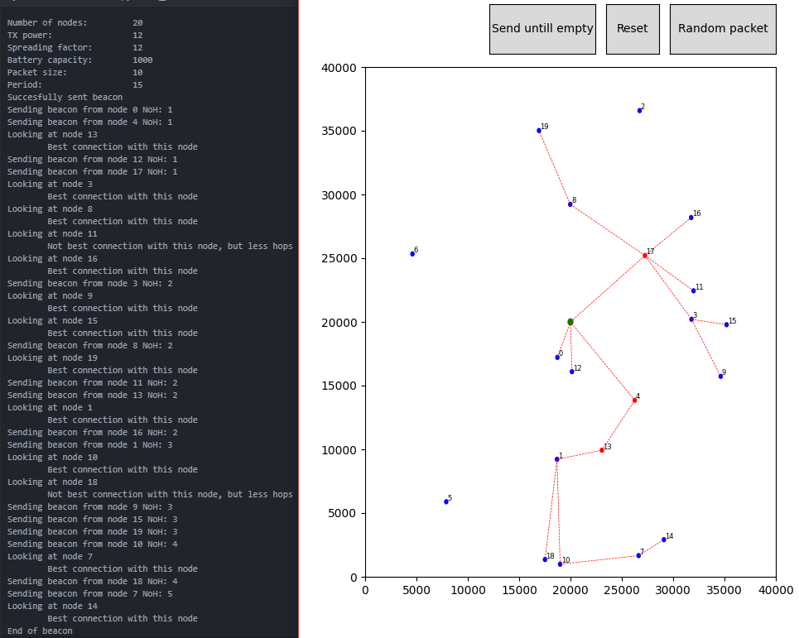

Figure 6: Connection decision node option 1 visualisation.

In Figure 5 a mesh setup using option one can be seen with debugging output. There are 2 cases were a node makes a connection, not based on the signal strength, but on how many hops it has otherwise.

Node 10 in the bottom of the plot is connected to node 1, because no other nodes in its vicinity have received a beacon yet and node 1 is the best connection with a node that does have a beacon. When node 1 tries to connect to node 18 (node left of node 10), it notices node 18 actually has a better RSSI when connected to node 10. But node 1 already has a connection with node 10, meaning the number of hops from node 18 to node 10 would be higher. Since node 18 can receive the beacon from node 1 without going through node 10 it chooses this connection.

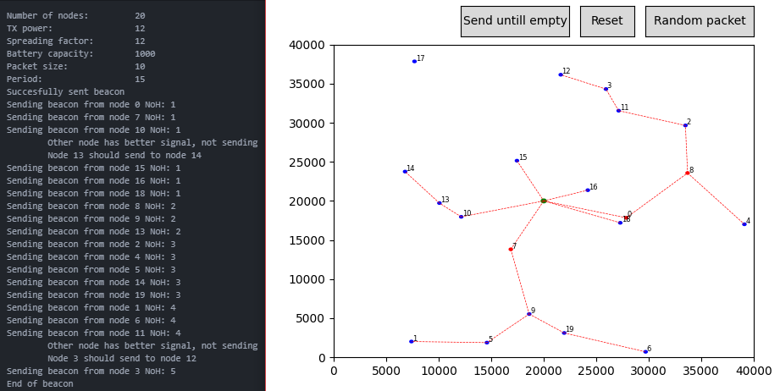

Figure 7: Connection decision node option 2 visualisation.

In Figure 6 a mesh setup using option two can be seen with debugging output. In this setup there were 2 cases where a node was trying to send a beacon to a node, but it realised another node is closer (better signal) to the node it is looking at. In the first case its node 14 that could have been connected to node 10, but instead chooses for the better connection, which is node 13.

**Conclusion**

When setting up the mesh network in the simulation, there are two choices:

**Option 1:** Connecting to a node so that it has the least number of hops to the gateway.

**Option 2:** Connecting to the node that has the best signal strength.

Both options have a negative and positive effects. For option one, since the nodes have the least number of hops, the nodes have to forward less packets compared to option two. The downside of this is that there are more connections with a longer range, and thus the minimum power required for sending a packet is increased.

For option two, nodes have to forward more messages compared to option one, resulting in spending more time receiving and sending packets. The upside is that the nodes are often closer to each other, meaning the minimum power required for sending a packet can be lowered.

Unfortunately, due to a decrease in time and with an eye for expediency some aspects of the project have been simplified and an implementation of a dynamic transmission power based on the distance between nodes has not been realised. Therefore, no comparison between the 2 options can be made inside the simulation. This addition is something that could be done in the future.

## Conclusion analyses & diagnoses

The analysis has shown that there is still much left to be researched. The first research question at paragraph 3.1 is still a very basic analysis due to the uncertainty of the LoRa mesh applications. Though fire detection system proves to be interesting it still requires a lot more research and a more thought-out product.

Paragraph 3.2 contains the research to determine the following parameters/variables: Transmission power (TP), Carrier Frequency (CF), Spreading factor (SF), Bandwidth (BW) and Coding Rate (CR). These where easily determinable since the LoRa Alliance was able to provide the necessary information for this subject.

As for paragraph 3.3 containing the focus points on the rules and regulations. The world is known to have the following regions: the European Union, the United States of America, the Peoples republic of China, the Commonwealth of Australia, the Republic of Korea (South Korea) and the Russian Federation. China appears to be the region with the most thought-out protocols, but this project will make use of the European regulations. This has been decided to make the future development suitable for the European market.

Paragraph 3.4 contains the research to determine which protocol is best suitable for the application. Research had been done for about 10 different protocols. Only 3 were listed in this report due to the lack of information about the other protocols. It also became clear that there are a lot of different protocols that could potentially be used but due to time constraints the decision was made to research the 3 protocols listed in 3.4. As it stands, it has been determined that the best protocol to use would be the protocol with the most information available. This would be the LoRaBlink protocol, since it did not vary too much from the other protocols, but it does include the most available information. This will be expanded upon in solution design.

Paragraph 3.5 establishes that it is preferable to only use quartz clocks for the synchronization. It could be possible to add a GPS system to it as well, but this would drain more power in what would become a static fire detection system.

Paragraph 3.6 shows the limitations of a LoRa mesh network. Although LoRa mesh brings a couple of benefits on increased range and a larger network, but it brings a number of drawbacks along with it. Most of the drawbacks like the increased power consumption, data rate and internal interference are caused by the fact that the nodes do not only need to communicate with the gateway, but also with other nodes. Finally one major downside of using a mesh network in the rural areas is the already existing LoRa coverage that makes a mesh network redundant.

Finally, Paragraph 3.7 establishes that Python would be the preferred programming method and is chosen for the simulation. There is also been determined that there are two possible ways to connect to different nodes by connecting them to the nodes with the least hops or with the best signal strength. This would require more research to determine the optimal choice. It would also be preferable to do market-based research to know the demands/requirements from the customers perspective.

# Program of requirements

This chapter will shortly discuss the program of requirements. Paragraph 4.1 discusses the chosen MoSCow method. Paragraph 4.2 contains and elaborates the requirments.

## MoSCow method

The MoSCow method consists out of 4 different components. A must have is a concrete demand that must be met. While A should have is a demand that can be deviated from. A could have is a nice to have and is not really a demand that must be met in anyway. A won’t have is a demand that will not be met in any way within the current project (Projectmanagementsite, 2021).

## Requirements

### Must have

* LoRa mesh protocol
* SX1276 LoRa chip
* Graphic representation of a randomly generated LoRa mesh network
* Multiple nodes minimum of 5 nodes
* Transmission power is adjustable
* Power consumption calculation
* The generated network must be simulated both in a vacuum and in air
* All rules in the simulation are based on the European standards

The mesh protocol is an essential part of the LoRa mesh network, the choice for this protocol has fallen on the Blink protocol. This choice is based on the research concluded in paragraph 3.4 where the protocol is shown to be the best choice in terms of the other protocols that were compared. Not only did it meet the minimal requirements, but it also showed to outperform the other protocols.

The simulation is based on a specific LoRa chip. The SX1276 LoRa chip is a popular chip used in various LoRa based products, this was concluded in various meetings with SODAQ. Different LoRa chips can be used in the simulation but will need to be adjusted in the simulation settings. The power consumption calculation is dependent on which chip is used. In the future there might be newer chips with less power consumption but for now the SX1276 is used for the simulation.

The LoRa mesh simulation can display randomly generated data. The data can be shown in a Python created plot and can display the LoRa gateway, nodes, and the connections between them. When a node has too many connections to the other nodes, it will show up as a red node and will give an error in the terminal. The user can use the generated plot as a visual representation of the created network.

For the simulation, a minimum of 5 nodes is needed to make the option viable in comparison with using a standard LoRa protocol. The Electrical Engineers have determined this together and reached a consensus with each other about this point. If a client wishes to use more nodes that is of course possible, but the maximum of this would be dependent on multiple factors that cannot be determined for this project. The most important factor would be the battery type and size used in combination with the required packet size.

The transmission is determined by the hardware aspects, in this case that would be the SX1276 LoRa chip described in sub paragraph 3.7.3. The reason that the transmission power must be adjustable is to give future developers the space needed to make their own adjustments and thus making sure that the simulation can be adjusted when needed.

The simulation can calculate the power consumption of each individual node. When a node sends a package to the gateway, it will use a standard amount of power which is dependent on the packet size and the used chip. When a node cannot send its data directly to a gateway, the node can send the data to another node which will then send the data to the gateway or another node. Nodes that also receive data will consume more power than nodes that only send data. For this reason, the power consumption of each individual node will be calculated in the simulation.

The standard simulation can simulate a network in a vacuum and in air. The optimal location for a network is in a vacuum, but because the determined use case is not located in a vacuum, the simulation will also need to be able to simulate within a standard environment such as air. The simulation in a vacuum can determine the theoretical possibilities of the network, while the simulation in air will show a more realistic result.

The final simulation must be based on the European standards that are determined in paragraph 3.3. These requirements are essential for the eventual implementation and usage of the LoRa mesh network. There are three points that must be met for this simulation which are: the duty cycle, frequency and spreading factor. The duty cycle must be below 1%, the frequency must be on 125 kHz and the spreading factor must be between 7-12 SF.

### Should have

* Randomized placing of the nodes
* Packet size of 100 Bytes
* When traffic on a node is too high the network will try to configurate to another path
* Adjustable parameters for different experiments

The simulation should have the possibility to randomize the placing of the nodes so that different situations can be simulated. This will also give future users of the program the possibility to create their own customized placing of the nodes and thus making the simulation more flexible.

The simulation is capable of simulating package sending from different nodes. These packets will be simulated with a size of 100 Bytes, this packet size has been determined in a meeting with Alessandro Verdiesen. The user can adjust the packet size dependent on the user’s application. The size of the packets will also have an impact on the power drain of each node. The simulation will calculate the power drain based on the given packet size.

When the connection between nodes is determined, specific nodes could potentially have too much traffic. The standard packet size send by a node is 100 Bytes. When a node has too many connections, there will be too many bytes send through that specific node. This will cause the nodes battery to deplete faster than the other nodes. How much traffic a node can handle is dependent on the application, battery and on how long the product is supposed to work. The simulation allows the user to specify how much traffic a node can handle. If a node has more traffic then the user specified amount, then the node will show up as a red node in the plot.

As for the adjustable parameters the simulation will be made in such a way that it is possible to program different hardware components and environmental factors. This is meant to make the simulation flexible and modular. This is because there is a multitude of different chips and situations that this solution could apply for.

### Could have

* The on/off time of each node could be considered in the simulation
* Temperature readings influence on signal strength
* Different obstacles in terms of materials

When simulating a LoRa mesh network, the on/off time of each node will be based on an ideal situation. This means that when a node is sending data, the receiving node will be listening at the exact same time. In a realistic situation this will not be the case because a perfect synchronization between nodes is not possible with the used hardware. This will cause nodes to listen for a longer period than they must. This will then cause the battery to drain faster. This can be considered in the simulation but is determined as a “could have” because SODAQ does not see it as a priority for this project.

The temperature readings of the surrounding area could be taken into consideration but is not a concrete demand since it is not the project groups objective to perform practical tests. Therefore, it is seen as a could have. As for simulating different obstacles in terms of materials falls in the same category as the last point and is considered as a nice to have due to the fact that there will be no practical tests. For this reason it will not be demanded from the simulation perse. The simulation will also only consider the ideal world as mentioned before, which would mean that there is no or barely any signal loss due to different factors.

### Won’t have

* Integration with existing SODAQ projects or products
* Practical tests
* Collision detection

The lack of integration with other SODAQ projects/products was already determined in the previously made PID. The company wants the project group to develop a new system that they can use for future projects or products on its own.

As for the practical tests due to the time investments needed into the programming any real-life tests proved to be impossible to instigate within the given time for this project. Another big factor is the harsher lockdown measures to contain the corona virus and its spread. This made it harder to meet and start any test at all.

The simulation will not consider collision detection. Collision detection is the detection of potential collisions of packets with other packets. If there are many nodes near one area there is a higher chance of the packets colliding with each other. The user would then be able to see in the simulation what the chances are of the packets colliding. At the start of the project, this was an expected part of the simulation. But due to time constraints, this part has not been considered.

# Solution design

This chapter will discuss the final results of the simulation. Paragraph 5.1 contains the final parameters. Paragraph 5.2 talks about the regulations/standards. Paragraph 5.3 contains the evaluation of the protocols. Paragraph 5.4 discusses the synchronizing of the nodes. Finally 5.5 evaluates previously made experiments.

## Final parameters

While writing the code for the simulation there were certain parameters that were not taken into consideration in the analyses phase. These are part of the link budget of a packet transmission Figure 8. The link budget is the sum of all the gains and losses from the transmitter, through the medium (free space), to the receiver (Eric, 2018). The cable loss (cable in figure) and antenna gain (ANT in figure) are not taken into consideration inside the simulation.

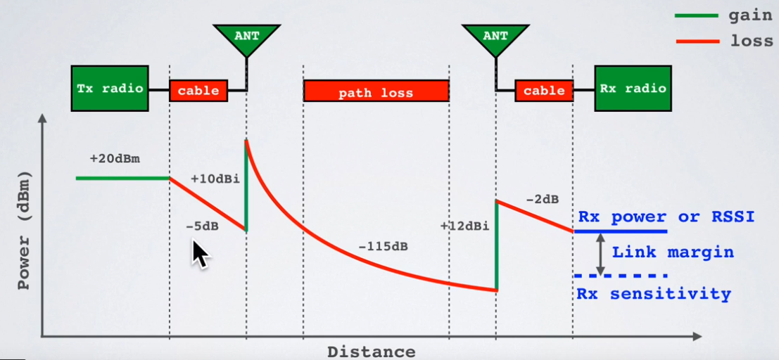

Figure 8: Link budget transmitter (Eric, 2018)

This paragraph will describe the different parameters that are used in the simulation, what the effects of these parameters are and how these parameters are implemented.

**Bandwidth**  
The bandwidth of the system can be set to 125kHz or 250kHz. The lowest bandwidth(125kHz) setting will result in the larger range and the lower data rate. The highest bandwidth(250kHz) will result in shorter range and higher data rates. The bandwidth cannot be changed for individual nodes.

**Carrier Wave frequency**  
The carrier wave frequency is dependent on regional regulations, which are often not far enough from each other to make a significant difference in the outcome. The higher the frequency of the carrier wave the higher the data rate and the lower the range. The frequency of the carrier wave used in the making of the simulation was 868MHz, which is the European standard.

**FSL (Free Space Loss)**The free space loss is the amount of strength the signal loses in a vacuum. This is the thing that first needs to be calculated before looking at other parameters that affect signal strength over distance.

**Atmospheric attenuation**  
Atmospheric attenuation is the amount of signal strength loss caused by the atmosphere. Different air conditions can be a factor in the amount of air attenuation that takes place. The amount of atmospheric attenuation is rarely higher than 0.02 dB/km with 2,4 GHz, which adds up to 1dB at a link of 50 km. This means that air conditions are fairly negligible (Afar, z.d.). In the simulation the effect of that the air has on the signal strength can be adjusted. It has been set at 0.006 dB/km; this value has been chosen because this seems to give the most realistic range of the nodes.

**Transceiver dependent parameters:**

**TX power (in dBm)**  
The main transceiver dependent parameter is the TX power. The transceiver SX1276 has 22 different transmit modes, from -2 dBm to 20 dBm. Each mode has its own current draw and can be found in the datasheet (Semtech Corporation, 2020). These current draw values are implemented in the simulation.

**Receiver sensitivity**Different transceivers can have different sensitivities for receiving data. This will have to be changed to the correct sensitivity if a different transceiver is used. The minimum sensitivity for receiving packets is also dependent on the BW (bandwidth), NF(Noise Factor) and SNR(Signal-to-noise) values. These SNR values are dependent on the spreading factor, this is displayed in Table 4 Spreading factor to SNR values. The receiver sensitivity in the simulation is determined by using the formula below.

*Rx sensitivity = -174 + 10log10(BW) + NF + SNR*

Table 4 Spreading factor to SNR values

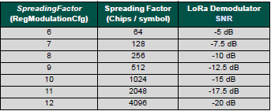

## World regulations/standards

Concluding this research question we can say that by the exception of China and north Africa, all regions are possible viable markets for the proposed technology, however it should be considered to conduct a local survey of the proposed location to make sure the effects induced by terrain and weather do not influence the functions of the application.

Legislation does not seem to be of great importance as long as the basic LoRa standard is met. The effects of terrain and weather can have a significant impact on the application, but this will vary based on the location and timeframe of use. Therefore, nothing can be done to anticipate for this effect except for making sure surveys are properly conducted before implementation.

## Evaluation of the protocols

In this paragraph the protocols will be evaluated based on the criteria stated in 3.4.1. First for each criterion will be stated what excellent, acceptable, minimum or insufficient is, then the protocols will be evaluated based on the criteria. According to these criteria the protocols will be evaluated and summarized in Table 5.

For each criteria a number of points are given. 4 points for every excellent score, 3 points for every acceptable score, 2 points for every minimum score and 1 point for every insufficient score. Then the total number of points decide the overall score of the protocol. The total number of points is 16, because there are 4 criteria with a points system and one criterion has a pass or fail score. 16 total points means an excellent overall score, 12-15 points for an overall acceptable score, 8-11 for an overall minimum score and 0-7 for an overall insufficient score.

The source code criteria are either a pass or fail. Because without the source code, the protocol cannot be used. This is the case for PM-LoRa, where the source code could not be acquired.

The information criteria are based on the amount of information that is available about the other criteria. It is considered excellent when there is enough information to successfully compare the criteria. The information criteria is considered minimum when one criteria does not have enough information available to be compared to the other protocols. The criteria is considered insufficient when there are more than one criteria that cannot be compared.

Because there is no clear definition of when a network needs to be synchronised, this criteria is based on the protocols compared to each other. An excellent score is given to the protocol that synchronises the most frequent, an acceptable score to the protocol second to the first and a minimum score to the protocol that synchronises the least often.

The battery life criteria are based on the number of messages the protocol needs to build up their network and on the number of messages needed to collect data from the nodes to the gateway once. An excellent score is given when a protocol only needs two messages to set up the network and collect data from the nodes. An acceptable score is given when the protocol needs 3-4 messages, a minimum score is given when the protocol needs 5-6 messages and an insufficient score when the protocol needs more than 6 messages.

The reliability criteria are based on the reliability of the LoRaWAN protocol, which is around 97% (Marco Cattani, 2017). An acceptable reliability will be between 90-97% and an excellent reliability would be higher than 97%. The reliability of the minimum score can be between 80-90%, because a way to increase the reliability is to send a second message after the first. With this a reliability of 80% can still get a reliability of 96% at the cost of more power consumption. When a reliability is lower than 80% it is deemed insufficient.

Table 5 mesh comparison

|  |  |  |  |
| --- | --- | --- | --- |
| Critiria | TSCH-over-LoRa | LoRaBlink | PM-LoRa |
| Source code criteria | Available (Pass) | Available (Pass) | Unavailable (Fail) |
| Information criteria | Insufficient (1) | Acceptable (3) | Minimum (2) |
| Synchronisation criteria | Every message and every 30 seconds with the gateway (4) | +/-5 minutes, depending on the epoch length (3) | There was not enough information to accurately compare (0) |
| Protocol criteria | There was not enough information to accurately compare (0) | 1 message per node for building the network.  1 message per node for collecting data (4) | 4 messages per node for building the network.  1 message per node for collection data (2) |
| Reliability criteria | There was not enough information to accurately compare (0) | 80% (2) | 97,6% (4) |
| Overall score | 5 | 12 | Fail, 8 |

|  |  |
| --- | --- |
| Legend | |
| 16 | Excellent |
| 12-15 | Acceptable |
| 8-11 | Minimum |
| 0-7 | Insufficient |
|  | Unavailable |

From Table 4 can be seen that the LoRaBlink scores the highest based on the criteria. LoRaBlink excels in the creating of a mesh network and the collecting of data, with a downside on the minimum score for reliability.

There is not enough information available about TSCH-over-LoRa to accurately compare the protocol to the other protocols. Because the documentation does not describe how the protocol builds its network. Neither does it provide any useful experiments to accurately determine the reliability of the protocol.

PM-LoRa has an incredible reliability, but takes more energy building the network. This fact might be redundant, as the network is only built once. As LoRaBlink builds its network every epoch, the PM-LoRa protocol keeps the network and saves power over a longer period of time. PM-LoRa might have been a competitor to LoRaBlink if the source code was available.

## Synchronizing the nodes

The Synchronisation of the nodes can be split op between two different subjects, the protocol synchronisation and the hardware synchronisation. The protocol synchronisation is entirely based on the synchronisation done by the rules of the protocol and the hardware synchronisation is based on the RTC that the individual nodes use.

**Protocol synchronization**

From paragraph 5.3 can be concluded that LoRaBlink is the protocol that will be used for the simulation. The synchronisation of the LoRaBlink protocol has already been explained in paragraph 3.4.2.

**Hardware synchronization**

The hardware needed for making sure every node in the network turns on and off at the same time are a RTC and optionally a GPS chip. This RTC can be a quartz clock that keeps time with an error margin of around 2 seconds a day. This error margin will have to be corrected for the system to stay synchronized. This will be done through either GPS or LoRa messages.

The two different clock time synchronization options from paragraph 3.5 are synchronizing time trough LoRa downlinks, or synchronising time trough GPS messages. One of them needs LoRa messages, the other needs a GPS chip and requires more power usage (ElectronicDesign, 2010).

Considering that the LoRaBlink protocol frequently sends out a beacon message every 5 minutes for synchronisation, the error margin of the quartz clock can be manageable through LoRa.

For the fire prevention system it could be the case that certain nodes are not in range of enough satellites to get a time stamp. Therefore it is recommended that the fire prevention system makes use of synchronization through LoRa.

## Comparison LoRaWAN and mesh

In chapter 3.6.1 8 experiments were set up; in this paragraph the results of these experiments will be evaluated.

* Time to live

It’s very apparent when looking at the time to live of the nodes, that with a faster data rate a way longer time to live can be achieved than with a lower one. The nodes with spreading factor 12 are able to stay alive for 100 days with no period, 200 with 5-minute period and highest transmitting power and about twice as long for both cases with the lowest transmitting power. The nodes with spreading factor 7 are able to stay alive for about 100 days with no period and almost 5000 days with 5-minute period, again when using the lowest transmitting power this time is almost doubled.

* Higher Power drain

Of course, the power drain of a node with a lot of traffic is a lot higher than when it is directly connected to a gateway. In the experiments it became clear that when a node has to forward data from one other node it will have significantly less time to live, especially in the case of experiment 4.

* Data rate lower

Having to forward messages leaves the nodes in a lot of time waiting after having sent their packets when sending with a period of 5 minutes. This means the packet from one node that has to be forwarded 3 times for example takes a very long time to finally reach the gateway. This results a relatively slow network compared to LoRaWAN.

* Collision in dense networks

This part was not included into the simulation but studies of (Rahmadhani & Kuipers, z.d.) have shown that frame collisions can occur when using LoRaWAN. When using multiple nodes on the same SF and BW, they will have colliding packets, resulting in information loss. Our expectation is that in a network of around 10 nodes a mesh network will start to have a declining reliability of sending packets.

* More range

With a mesh network you have the benefit of a much longer range. Nodes can theoretically be stringed together forever, only this would not be manageable in reality. With every node in spreading factor 12 and the highest transmission power, each connection could be around 12 km long (result gotten from simulation). This way a range of around 36 km from node to gateway can be realised with only 3 nodes.

* Higher reliability

Having the ability to send data to another node means nodes are able to send the same data as other nodes. Theoretically when data is not correctly received for some reason, other nodes could retransmit that same data in order to reliably get the information where it needs to go.

**Evaluation traffic**

In attachment 6 2 graphs are shown where the time to live is set out against the traffic over the node. There is a quite noticeable drop from 0 to 1 traffic and also from 1 to 2 traffic. Once a node gets more traffic, the time to live starts to even out. The node has reached its limits in terms of traffic because it has to forward so many packets, it spends a whole lot more energy receiving the packets being sent by other nodes.

# Projectmanagement

Besides all the technical details, the project also needed to be managed. This chapter covers all the project management details that went into completing this project. The first sub-chapter covers the different methods that were used during the project in each different period. The second sub-chapter takes a deeper look at the SCRUM project method. The third sub-chapter covers the different roles of each group member. The fourth and las sub-chapter shows the milestones that were originally set in the PID and clarifies which ones have been completed.

## Project methods

In the start of the project some aspects were unclear. For starters, the use case of the product that SODAQ wanted was unclear. When researching what the product could potentially be used for it quickly became clear that a LoRa mesh network would not be beneficial for most applications. The reason for this will be further clarified in chapter 7: Conclusion & recommendations. For this reason, the project used different methods throughout the entire project. Which methods have been used will be discussed in the next few sub-chapters.

### Start

At the start of the project, it was very unclear to what the best way would be to handle it. The Waterfall or SCRUM method could have been used to create structure in the project but because the milestones and objectives were unclear it was hard to set specific goals and phases. For the start of the project a Trello had been set up for the aspects that were clear enough to be dissected. Short time objectives were set in the Trello and executed to make sure that progress would still be made. Other method options were considered as the project become more comprehensible.

### Mid

In the mid-section of the project, around the 1st of November in 2020, the long-term goals of the project became clearer. When the long-term goals were set, the project could move in one direction and start using a project method. The method used for the project in the mid-section was the SCRUM method. This method was used because it has the flexibility to work ahead and to chance aspects of the project from the past, unlike other project methods such as the Waterfall method. No physical SCRUM board had been made for the project due to COVID-19 causing everyone to work mostly from home. The Trello from the start of the project was rearranged as a SCRUM board so that it could be used to easily disturbed tasks between the group. Sprint reports were also set up at the end of each sprint, this will be covered in chapter 6.2.1.

### End

After working with SCRUM until about the 14th of December, the end of the project came closer. It quickly came clear that not all the deadlines would be met by the end of the project. Because of this reason the sprint reports were scrapped from the project to save time. Decisions were made to determine which aspects of the project would be delivered. The decision was made to deliver a simulation of the network and the research. The hardware development phase was scrapped due to time constraints. For the end of the project, it was required to work towards the different deadlines of the simulation and the final report. For this reason, a specific project method was not used for the last 5 weeks of the project. Different deadlines were set every week to determine what had to be finished to continue the project in the next week.

## SCRUM

For the mid-section of the project, the SCRUM method was used to create structure within the project. At the start of every week, on Monday, decisions were made to set deadlines for the end of that week. The tasks were split between the group members. At the end of each week an evaluation was made, put into the sprint report, and used when creating new tasks in the following sprint. The Trello was used to keep track of the tasks.

### Sprint reports

Every week a sprint report was made to evaluate the tasks that were done in the previous week. This sprint report clarifies what parts of the project have been worked on and by who. An example of a sprint report can be found in attachment 7. The sprint report also shows which user stories have been worked on, the personal tasks and the burndown chart.

## Member roles

The individual roles of each member have already been clarified in the Quest contract, but for extra clarification it is shown in this final report as well (Jari de Haas, 2020).

The Quest group for the SODAQ project consists of five students, these students come from different backgrounds and studies to make up a multi-disciplinary team. The students and their respective roles are named as follows:

* Maarten van Dijk – Electrical Engineer - Assistant project lead
* Jari de Haas – Business process Engineer
* Nick Jans – Electrical Engineer – Project lead
* Stijn Vergouwen – Electrical Engineer
* Menno Weijers – Electrical engineer - Note-taker
* Thomas Kinket – Business process Engineer

Aside from the student team there are other stakeholders involved in this project. There are stakeholders from the client and the university that have a say or interest in the project. These people and their respective roles are named as follows:

* Itay Dagan – SODAQ CTO
* Hubert Schuit – 1st Assessor
* Jan Willem Smeenk – SODAQ CEO
* Alessandro Verdiesen - Junior Project Manager

## Milestones

In the Quest contract a few milestones were set. The first deliverables of the project were the Quest contract and the cooperation agreement. These deliverables were originally set to be finished at 02/10/2020. The first few drafts of the Quest contract were not of satisfaction to the client. Therefore, the final version of the contract was delivered on 22/10/2020.

The next milestones were the project initiation document and a presentation. These deliverables were set to be finished at 23/10/2020. Because the Quest contract took longer than expected, the PID also had to be delayed. This milestone was delivered on 9/11/2020. The presentation about the progress of the project for the stakeholders was held on 10/11/2020.

The final milestones are the end product, video of the end product, professional functioning assessment and a final presentation for the stakeholders. The end product and the video were supposed to be finished on 22/1/2021. The assessment and the final presentation were meant to be finished on 29/1/2021. All these milestones were pushed into the week of 25/1/2021.

# Conclusion & recommendation

This chapter serves to answer the main question as it was presented in the PID the question intended to answer several questions asked by SODAQ, the question being:

*“How can a synchronous power-state LoRa mesh network be realised for SODAQ applications? “*

The short answer to this question is that SODAQ can expand upon the supplied simulation and use this to develop and implement Mesh in their products. The long answer however is more complicated. Due to multiple factors that will be discussed in the coming paragraphs, **LoRa mesh is deemed to be unfavorable as compared to LoRaWAN**. This conclusion stems from the absence of significant advantages where sacrifices will be made in order to achieve nothing.

This conclusion will be divided into its multitude of facets and factors below which shall be split up in the following paragraphs. Paragraph 7.1 will discuss the findings and conclusions regarding the technological aspects of LoRa mesh. Paragraph 7.2 states the conclusions and their reasoning about the practical use of LoRa mesh. Paragraph. Paragraph 7.3 lists the multitude of research directions which can be explored to answer questions which have been foregone due to the limiting scope of this project. Paragraph 7.4 states the recommendations regarding the further development and use of LoRa mesh.

## Conclusions Regarding LoRa mesh Technology

In this paragraph a conclusion regarding the technical aspects of LoRa mesh will be given. The conclusion is based on the research and experiments done throughout the project.

One downside of the LoRa mesh network is the increase of power consumption among nodes, when compared to a LoRaWAN network. The increase of power consumption is to be expect, because the nodes need to provide a number of new functions that was not needed with a LoRaWAN network. So is collecting data from the nodes only done by the gateway in a LoRaWAN network. But with a LoRa mesh network, the nodes themselves are in charge of collecting the data from nodes outside the range of the gateway. In attachment 6 can be seen the effects of a mesh network on the power consumption of a node. In experiment 1 of the attachment can be seen that a node without traffic can last 224 days sending a message every 5 minutes, what can be seen as a point-to-point system. When a node does have traffic from other nodes to receive and send to the gateway, then the network turns into a mesh network. A node can last between 208 and 185 days depending on the number of nodes attached to the node. In conclusion the nodes in a mesh network have a reduced battery life of 92,9% to 82,6% in comparison to LoRaWAN.

Another downside of LoRa mesh compared to the LoRaWAN is the lower reliability LoRa mesh has. As the LoRaWAN network usually achieves a reliability of 97%, the LoRa mesh network with the LoRaBlink protocol achieves a reliability of 80%.

One advantage LoRa mesh has over the LoRaWAN is the increase in range. As the LoRaWAN networks are limited to the range of their gateways, the LoRa mesh is not. The range of LoRa mesh can variate depending on the amount of traffic a node can handle. In theory it could be infinite, as long as the nodes do not excrete any of the limitations of LoRa or run out of battery life. Unfortunately having a large range might not be that useful, as most of Europe is covered with the LoRaWAN public network.

The SX1276 chip has been chosen to base the simulation around. This is done because this chip is well known with SODAQ and is one of the most widely used LoRa chip on the market. Another chip could be implemented into the simulation, but the parameters should be altered accordingly. Other hardware which no doubt has to be used in a real-life node like an MCU, a sensor and maybe a solar panel etc. are not implemented into the simulation and therefore no conclusion can be made about these subjects.

## Conclusions Regarding the use of LoRa mesh

During this project several setbacks were encountered regarding the potential use cases of a LoRa mesh network. It was established that it is not considered viable to implement any Mesh network using the LoRa standard. The following reasons have been found:

* Range of the Mesh network may vary per implementation, but the battery drain to achieve this range will always exceed that of a LoRaWAN connection of the same range.
* Due to full area coverage by The Things Network it is considered to be unnecessary to use LoRa mesh over LoRaWAN for most applications.
* Due to the higher power drain of LoRa mesh it is expected that use of LoRa mesh will result in higher initial purchase costs and higher operating cost as compared to LoRaWAN.
* Due to the expected interference associated with operating a LoRa mesh network the data rate of the signal will most likely have to be reduced, resulting in a less effective and efficient network.

## Recommendations regarding further Research

As a result to the conclusion a list of further research possibilities has been constructed. These proposed studies are regarded as essential to reach a rudimentary state of development for LoRa mesh as a commercial technology. The recommendations for further research are listed below and contain a short description of the proposed scope and its value.

### Further development of the simulation.

To be of practical use to SODAQ the simulation will have to be expanded to include more options for network design and part selection, also it might be beneficiary to include more environmental factors.

### Hardware possibilities.

In order to design a proper application for this technology more knowledge regarding suitable hardware needs to be gathered, preferably resulting in collection of suitable parts.

### Comparative study regarding LoRaWan and LoRa mesh.

In order to simplify the decision-making process between the use of LoRaWAN and LoRa mesh a study is recommended to establish baseline factors for systematic decision making.

### Study regarding the influence of LoRa mesh on battery life.

Although some attention has been paid to the battery consumption of a proposed Mesh, none have been tested, it is deemed important that this factor be extensively researched before synthesizing a physical LoRa mesh application.

### Study regarding the influence of interference on the LoRa mesh structure.

In the present simulation no effort was made to study and implement interference in the simulation, due to the possible effects it may have on the function of a Mesh network it is recommended to study this factor separately.

### Study regarding the influence of the built environment on the LoRa mesh structure.

While conducting studies into external factors it was recognized that the environment itself has a significant impact on the practical range of individual nodes depending on their surroundings. It is recommended that an extensive study be dedicated to categorizing and measuring these effects properly.

## Recommendations regarding commercial application

Due to the reasons stated in Paragraph 7.2, SODAQ is advised to not start implementation of LoRa mesh in its products. The Technology does not seem to have achieved any viable advantages and is thus not beneficial to incorporate in the product lineup. The future of LoRa mesh is not directly apparent to the project team or the LoRa community, therefore SODAQ is also advised to conduct (or outsource to student teams) more research into the relevant factors as stated above in paragraph 7.3.

Furthermore, SODAQ is strongly advised to not start development of any LoRa mesh products or applications without having the end goal thoroughly documented and reviewed, as the application itself is currently key to the Go/No-go decision.

It must also be said that the unique traits of a LoRa mesh may prove invaluable in certain cases where external factors dictate a scope which calls for this technology

# Bibliography

AFAR Communications, Inc. (z.d.). *900 MHz versus 2.4 GHz in long distance links*. Retrieved from Afar: http://afar.net/tutorials/900-mhz-versus-2-4-ghz/

Afar. (z.d.). *900 Mhz versus 2.4 Ghz in long distance links*. Retrieved 1 22, 2021, from Afar: http://afar.net/tutorials/900-mhz-versus-2-4-ghz/

Aken, J. v. (2007). *Problem solving in organizations.* Cambridge, VK: Cambridge university press.

Akvo. (2020, November 14). *Better data, bigger impact*. Retrieved November 14, 2020, from www.akvo.org: https://akvo.org/

Ali, I. (2020, September 25). *Role of RTC(Real Time Clock) in Embedded Devices*. Retrieved from iqramali.medium.com: https://iqramali.medium.com/role-of-rtc-real-time-clock-in-embedded-devices-35dbd2e8f9e7

Alliander. (2020, November 14). *Wij geven vorm aan de energietoekomst van Nederland*. Retrieved November 14, 2020, from www.alliander.com: https://www.alliander.com/nl/over-alliander/

Amajama, J. (2016). *Impact of Weather Components on UHF radio signals.* Calabar Nigeria: Physics Department – University of Calabar.

Atos. (2020, November 14). *About us*. Retrieved November 14, 2020, from www.Atos.net: https://atos.net/en/about-us

Bankole, K. (2018, February 5). *Tutorial: Build an open source smart city with LoRaWAN*. Retrieved November 18, 2020, from www.medium.com: https://medium.com/kkbankol-events/tutorial-build-a-open-source-smart-city-based-on-lora-7ca76b9a098

Bayer. (2020, November 14). *Shaping Agriculture for Farmers, Consumers & the Planet*. Retrieved November 14, 2020, from www.bayer.com: https://www.bayer.com/en/crop-science/crop-science-division

Bor, M. C., & Roeding, U. (2017). *LoRa Transmission Parameter Selection.* Lancaster: Lancaster University.

Boskalis. (2020, November 14). *Research and development*. Retrieved November 14, 2020, from www.boskalis.com: https://boskalis.com/about-us/company-profile/research-and-development.html

Centraal Bureau voor de Statistiek. (2019, November 28). *Meeste oppervlakteleegstand bij kantoren en winkels*. Retrieved December 16, 2020, from www.cbs.nl: https://www.cbs.nl/nl-nl/nieuws/2019/48/meeste-oppervlakteleegstand-bij-kantoren-en-winkels

Design a Better Business. (2020, December 14). *Persona Canvas*. Retrieved December 14, 2020, from www.designabetterbusiness.tools: https://www.designabetterbusiness.tools/tools/persona-canvas

Dijk Van, E. (2020, December 14). Senior account zakelijke verzekeringen. (T. Kinket, Interviewer) Retrieved December 14, 2020

Dp. (2020, November 14). *Duijvelaar Pompen*. Retrieved November 14, 2020, from www.dp.nl: https://dp.nl/corporate

ElectronicDesign. (2010, November 3). *GPS Module Consumes Little Power*. Retrieved from ElectronicDesign: https://www.electronicdesign.com/technologies/embedded-revolution/article/21792175/gps-module-consumes-little-power#:~:text=An%20all%2Din%2Done%20component,and%2030%20mA%20during%20acquisition.&text=of%20Enlarge%20image-,An%20all%2Din%2Done%20component%2C

Eric, B. (2018). *LoRa*. Retrieved from Read the docs: https://lora.readthedocs.io/en/latest/

Frama. (2020, November 14). *Frama*. Retrieved November 14, 2020, from https://www.frama.nl: https://www.frama.nl

Gakstatter, E. (2015, Februari 4). *What exactly is gps nmea data*. Retrieved from gpsworld.com: https://www.gpsworld.com/what-exactly-is-gps-nmea-data/

Huh, H., & Kim Yeol, J. (2019). *LoRa-basedMesh Network for IoT Applications.* Retrieved December 16, 2020, from www.jkjmanagement.com: https://www.jkjmanagement.com/wfiot/papers/1570506788.pdf

*INNOVATE. ACCELERATE. MAKE IT HAPPEN.* (2020, November 14). Retrieved November 14, 2020, from www.portofrotterdam.com: https://www.portofrotterdam.com/en/doing-business/port-of-the-future/innovation/innovation-smartest-port

Iotspot. (2020, November 14). *Iotspot*. Retrieved from www.iotspot.co: https://iotspot.co/

Jari de Haas, M. v. (2020). *Quest contract.* Utrecht: Hogeschool Utrecht.

Kinetron. (2020, November 14). *Markets*. Retrieved November 14, 2020, from https://www.kinetron.eu/: https://www.kinetron.eu/

KPN. (2020, November 19). *Connectiviteit via het LoRa-netwerk*. Retrieved November 19, 2020, from www.kpn.com: https://www.kpn.com/zakelijk/internet-of-things/lora-netwerk.htm

Krone. (2020, November 14). *Krone*. Retrieved November 14, 2020, from www.krone-nederland.nl: https://www.krone-nederland.nl/nederlands/

Lombardi, M. (2008, Februari). *The Accuracy and Stability of Quartz Watches*. Retrieved from Researchgate.net: https://www.researchgate.net/publication/269432051_The_Accuracy_and_Stability_of_Quartz_Watches

LoRa Alliance. (2020, November 19). *LoRa Alliance*. Retrieved November 19, 2020, from https://lora-alliance.org/: https://lora-alliance.org/

LoRa-Alliance. (2015, January). *LoRaWAN specification*. Retrieved from https://lora-alliance.org/sites/default/files/2018-05/2015_-_lorawan_specification_1r0_611_1.pdf

LoRa-Alliance. (2020, 02 20). *RP002-1.0.1 LoRaWAN Regional Parameters.* Retrieved from LoRa Alliance: https://lora-alliance.org/sites/default/files/2020-06/rp_2-1.0.1.pdf

Lova, O. (2017). *LoRa from the City to the Mountains:.* Trento, Italy: University of Trento.

Mai Dinh Loc, M. K. (2019, 12). *Multi-Hop LoRa Network with Pipelined Transmission Capability*. Retrieved 1 15, 2021, from www.researchgate.net: https://www.researchgate.net/publication/338139697_Multi-Hop_LoRa_Network_with_Pipelined_Transmission_Capability

Marco Cattani, C. A. (2017, 06). *An Experimental Evaluation of the Reliability of LoRaLong-Range Low-Power Wireless Communication*. Retrieved 01 15, 2021, from www.researchgate.net: https://www.researchgate.net/publication/317823578_Evaluation_of_the_Reliability_of_LoRa_Long-Range_Low-Power_Wireless_Communication

Martin Bor, J. V. (2015). *LoRa for the Internet of Things.* Lancaster: Lancaster University.

Martin Haubro, e. a. (2020, 04 13). *TSCH‐over‐LoRA: long range and reliable IPv6 multi‐hop networks for the internet of things*. Retrieved 12 15, 2020, from onlinelibrary.wiley.com: https://onlinelibrary.wiley.com/doi/full/10.1002/itl2.165

Myndr. (2020, November 14). *Word de baas over je aandacht*. Retrieved November 14, 2020, from https://www.myndr.nl/: https://www.myndr.nl/

*Never lose your cattle*. (2020, November 14). Opgeroepen op November 14, 2020, van www.moovement.com.au: https://www.moovement.com.au/

*Organisatie*. (2020, November 14). Retrieved November 14, 2020, from www.prorail.nl: https://www.prorail.nl/wie-zijn-we/organisatie

Philips. (2020, November 14). *Smart Solutions for Industry 4.0*. Retrieved November 14, 2020, from www.innovationservices.philips.com: https://www.innovationservices.philips.com/smart-solutions/

Politie. (2020, July 1). *Welkom bij iLab*. Retrieved November 14, 2020, from www.politie.nl: https://www.politie.nl/themas/ilab-innovatielab.html?sid=65ee8906-df93-4fdc-9648-56e64ea24fcd

Projectmanagementsite. (2021, January 18). *MoSCoW*. Retrieved January 18, 2021, from www.projectmanagementsite.nl: https://projectmanagementsite.nl/moscow/

Rahmadhani, A., & Kuipers, F. (z.d.). *Understanding collisions in a LoRaWAN.* Retrieved from Delft University of Technology: https://www.google.com/url?sa=t&rct=j&q=&esrc=s&source=web&cd=&ved=2ahUKEwj5zufwtJjtAhWBzKQKHQ67Cx0QFjAAegQIARAC&url=https%3A%2F%2Fwiki.surfnet.nl%2Fdownload%2Fattachments%2F11211020%2FTUD-LoRaWAN-RoN-2017.pdf%3Fversion%3D1%26modificationDate%3D1528101295

Rainforest Connection. (2020, November 19). *The most impactful way to stop climate change? Save rainforests.* Retrieved November 19, 2020, from www.rfcx.org: https://www.rfcx.org/

Rijksoverheid. (2012). *BRIS bouwbesluitonline*. Retrieved December 16, 2020, from www.bouwbesluitonline.nl: https://www.bouwbesluitonline.nl/docs/wet/bb2012/hfd1/par1-5

Semtech Corporation. (2020, May). *Semtech SX1276*. Retrieved from semtech: https://www.semtech.com/products/wireless-rf/lora-transceivers/sx1276

sigfox. (2020, November 19). *Coverage*. Retrieved November 19, 2020, from www.sigfox.com: https://www.sigfox.com/en/coverage

Smartmakers. (2019, March). *LoRaWAN-Range, Part 1: The most important factors for a good LoRaWAN radio range*. Retrieved from Smartmakers: https://smartmakers.io/en/lorawan-range-part-1-the-most-important-factors-for-a-good-lorawan-signal-range/

SODAQ. (2020, November 18). *SODAQ PRODUCTS*. Retrieved November 18, 2020, from www.sodaq.com: https://sodaq.com/products/

SODAQ. (2020, November 18). *WE SEE A WORLD WITHOUT BATTERIES*. Retrieved November 18, 2020, from www.sodaq.com: https://sodaq.com/company/

SODAQ. (2020, November 14). *WE SEE A WORLD WITHOUT BATTERIES*. Opgeroepen op November 14\, 2020, van www.sodaq.comq: https://sodaq.com/company/

Soffer, A. (2019, June 15). *The 5 Most Popular Methods of Segmentation for B2B*. Retrieved November 14, 2020, from www.leadspace.com: https://www.leadspace.com/popular-methods-of-segmentation-for-b2b/

Sport Technologies. (2020, November 14). *Duurzaamste LED verlichting*. Retrieved November 14, 2020, from www.sport-technologies.nl: https://sport-technologies.nl/

Techplayon. (2007, November 7). *LoRa (Long Range) End Device Classifications*. Retrieved from Techplayon: http://www.techplayon.com/lora-long-range-end-device-classifications-class-class-b-class-c/

The things Network. (2020, ob ob). *Lorawan frequencies by country*. Retrieved from Thethingsnetwork: https://www.thethingsnetwork.org/docs/lorawan/frequencies-by-country.html

TKH Security. (2020, November 14). *Market Segments*. Retrieved November 14, 2020, from www.tkhsecurity.com/: https://tkhsecurity.com/

Van Oord. (2020, November 14). *Founder’s mentality*. Retrieved November 14, 2020, from www.vanoord.com: https://www.vanoord.com/about-us

*Wat is waterbeheer?* (2020, November 14). Retrieved November 14, 2020, from www.waternet.nl: https://www.waternet.nl/over-ons/waterbeheer/

# Attachment 1 Phone call Centraal Beheer Achmea

Eddy van Dijk Senior Account zakelijke verzekeringen Centraal Beheer Achmea (Dijk Van, 2020)

* Er zijn risicoklassen 1, 2 en 3 voor verzekeren
* Brandbeveiligingen worden vanuit de gemeente/brandweer met algemene richtlijnen geregeld voor minimale eisen aan beveiliging tegen brand
* VRKI kaart voor classificaties
* Leegstaande panden worden niet verzekerd tegen brand
* Een goedkoop brandbeveiliging systeem kan interessant zijn om tegen leegstand te beschermen voor zakelijke partners, omdat leegstand toch een groeiend fenomeen is
* Kan ook interessant zijn voor particulieren
* Het moet wel goedkoop zijn
* Achmea is nu druk bezig om een nieuw systeem te implementeren en heeft het komende jaar geen tijd om hier actief naar te kijken

# Attachment 2 Persona canvas

Table 6 Persona canvas Centraal beheer Achmea

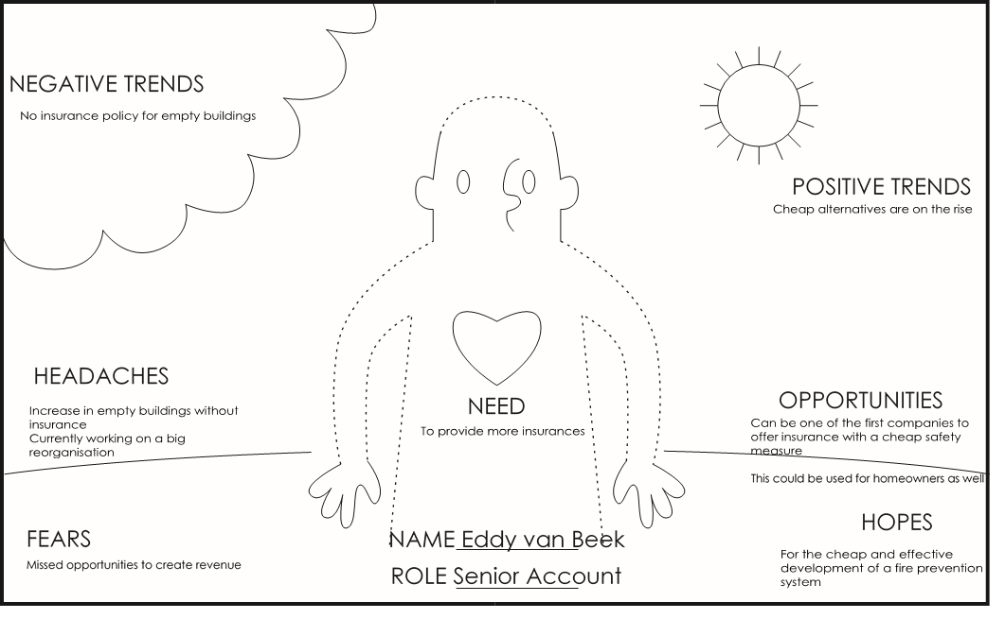

Table 7 Persona canvas office owner

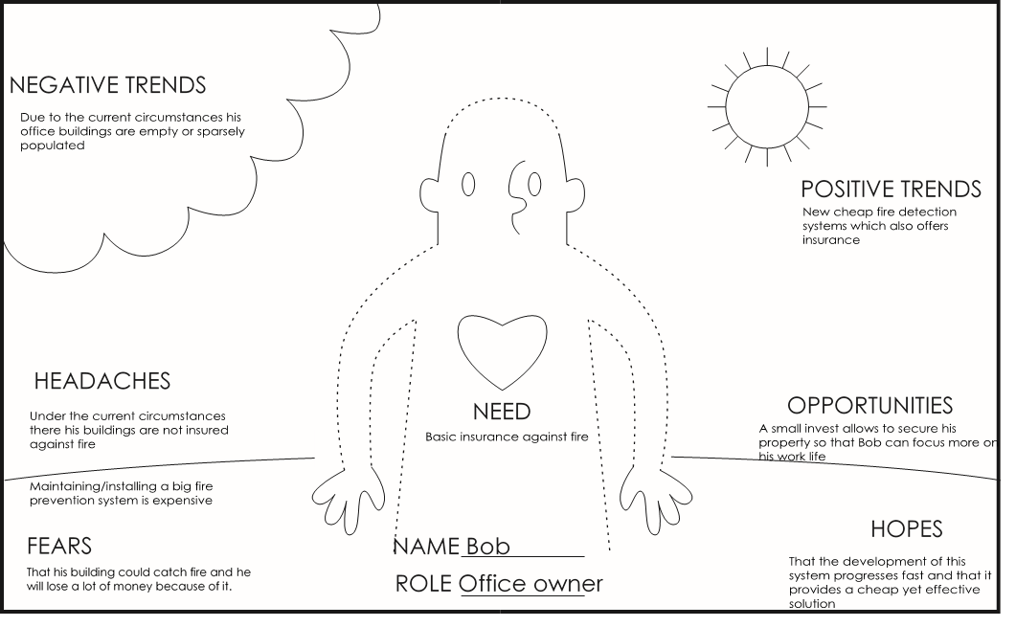

# Attachment 3 Current draw SX1276 & SX1262

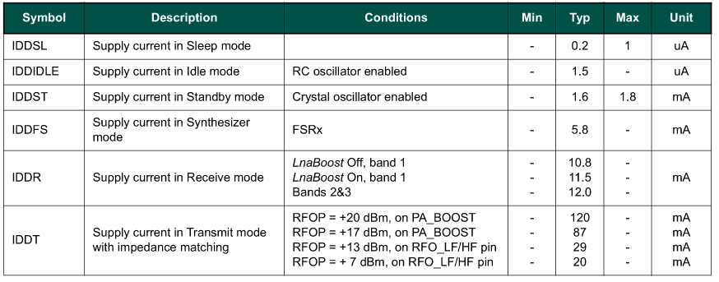

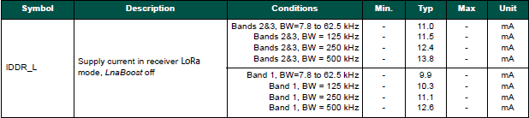

Figure 9: SX1276/77/78/79 current draw in receiver modes, only band 1, BW=125 kHz is used.

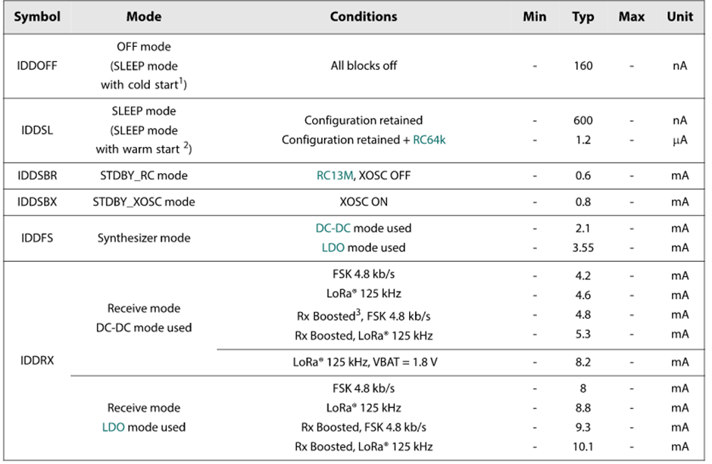

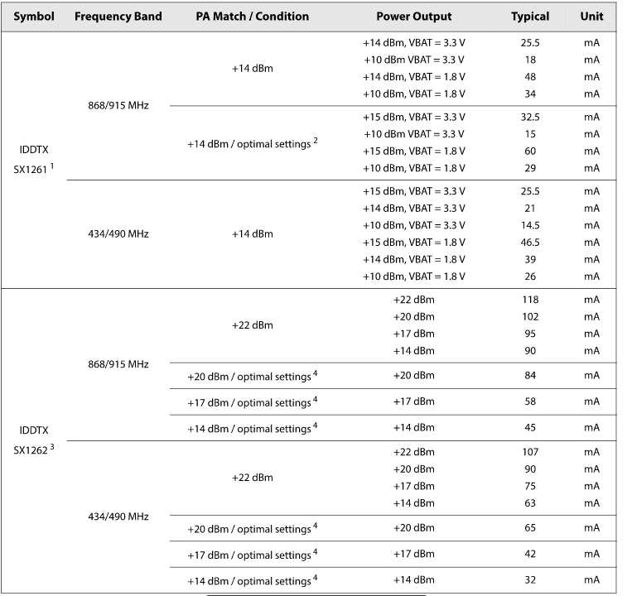

# Attachment 4 Flowchart LoRaSimSODAQ.py

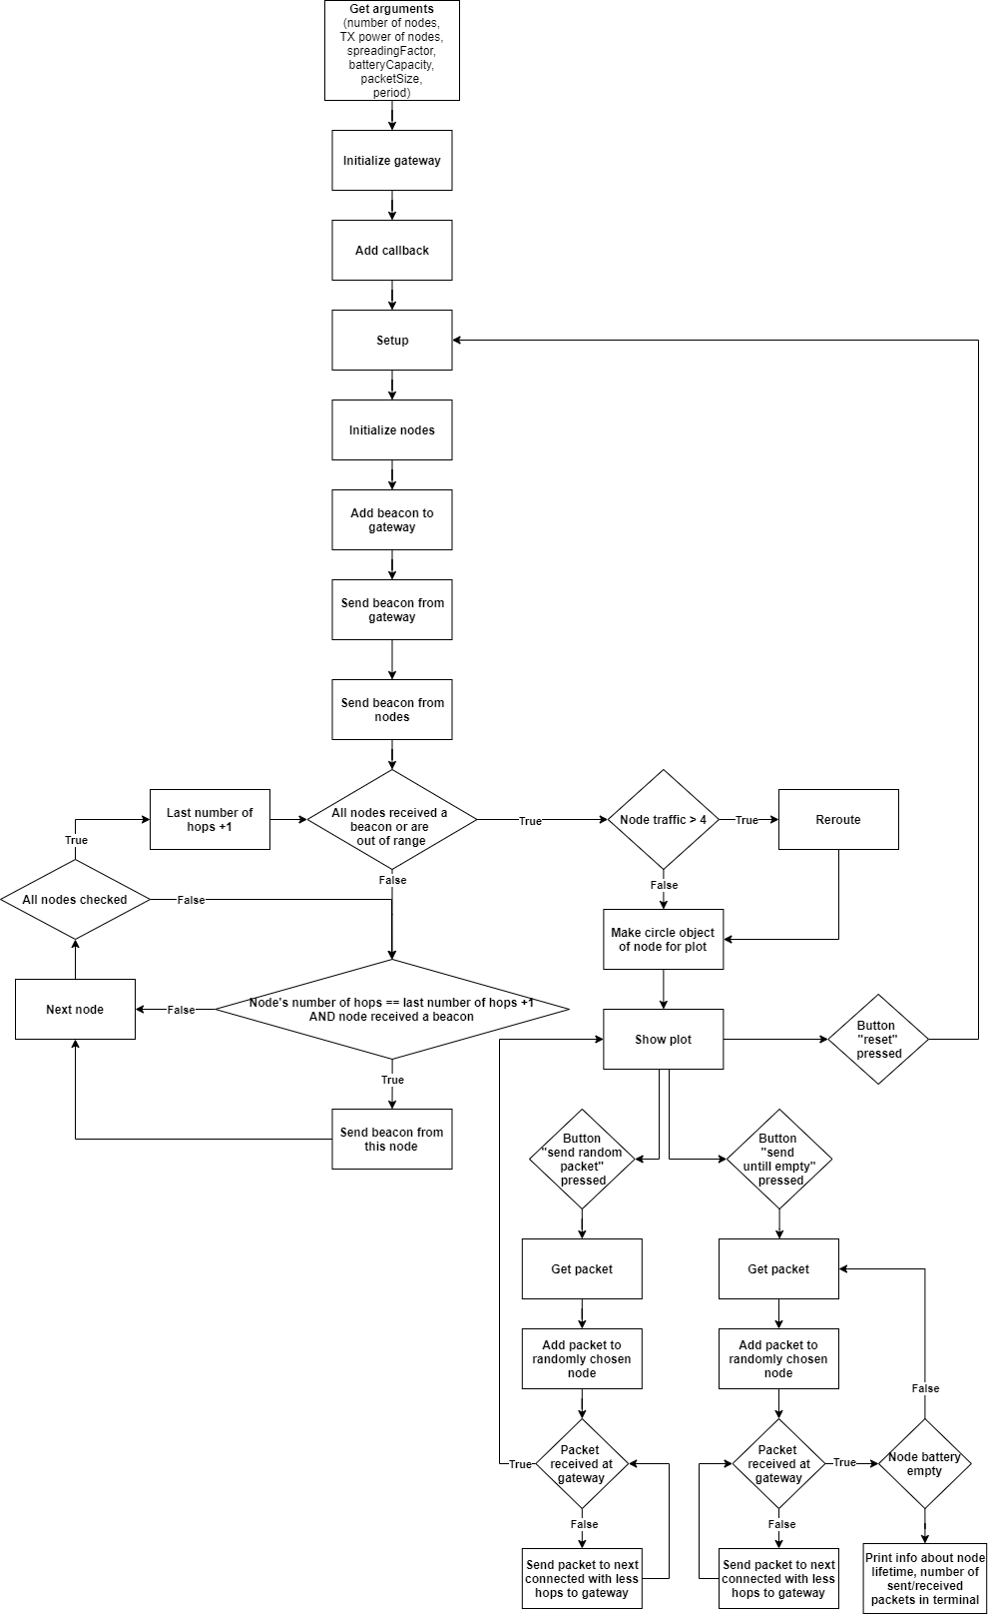

# Attachment 5 Different legislation regions.



# Attachment 6 Simulation experiments excel sheet



# Attachment 7 Sprint report

**SPRINT REPORT**

|  |  |
| --- | --- |
| Sprint | 2 |
| Projectgroep | SODAQ |
| Datum | 8-11-2020 |
| 1. Stijn Vergouwen | 1682145 |
| 2. Maarten van Dijk | 1744469 |
| 3. Nick Jans | 1717809 |
| 4. Jari de Haas | 1738478 |
| 5. Menno Weijers | 1740474 |
| 6. Thomas Kinket | 1732713 |

**Inhoudsopgave**

Abstract 1

Table of contents 2

1 Preface 1

2 Project description 2

2.1 Company description 2

2.2 Problem definition 2

2.3 Project scope 5

2.4 Results and deliverables 7

2.5 Potential customers 10

2.6 Strategic importance 12

3 Analyses & diagnoses 13

3.1 Possible applications for a viable for LoRa mesh in a commercial setting 13

3.2 Necessary parameters to develop a LoRa mesh network 14

3.3 Regulations, legislation and external factors that influence the application of LoRa mesh 16

3.4 Existing LoRa mesh protocols for the simulation 19

3.5 The most suitable method for keeping individual nodes synchronized 23

3.6 Limitations of the LoRa mesh network 24

3.7 Realizing a LoRa mesh simulation 26

3.8 Conclusion analyses & diagnoses 32

4 Program of requirements 33

4.1 MoSCow method 33

4.2 Requirements 33

5 Solution design 37

5.1 Final parameters 37

5.2 World regulations/standards 38

5.3 Evaluation of the protocols 39

5.4 Synchronizing the nodes 41

5.5 Comparison LoRaWAN and mesh 42

6 Projectmanagement 44

6.1 Project methods 44

6.2 SCRUM 45

6.3 Member roles 45

6.4 Milestones 45

7 Conclusion & recommendation 47

7.1 Conclusions Regarding LoRa mesh Technology 47

7.2 Conclusions Regarding the use of LoRa mesh 48

7.3 Recommendations regarding further Research 48

7.4 Recommendations regarding commercial application 49

Bibliography 50

Attachment 1 Phone call Centraal Beheer Achmea 54

Attachment 2 Persona canvas 55

Attachment 3 Current draw SX1276 & SX1262 56

Attachment 4 Flowchart LoRaSimSODAQ.py 58

Attachment 5 Different legislation regions. 59

Attachment 6 Simulation experiments excel sheet 60

Attachment 7 Sprint report 63

**Sprint doel**

Het doel van de sprint is het uitvoeren van de tasks in de product backlog. Tijdens deze sprint wordt er gewerkt aan de onderzoeksvragen en het realiseren van de simulatie. Het PvA wordt ook opgeleverd tijdens deze sprint. Alle parameters voor de simulatie worden vastgesteld en toegelicht. De verschillende mogelijk protocollen worden onderzocht en duidelijk gedocumenteerd, alle verschillende opties worden toegelicht. Er wordt een opzet gemaakt voor het eindverslag en er wordt een presentatie gegeven aan de opdrachtgever en de schoolbegeleiders. Als laatst wordt de wet en regelgeving rond LoRa onderzocht en de verschillende gebruikslocaties worden onderzocht op omstandigheden.

**Sprint Backlog**

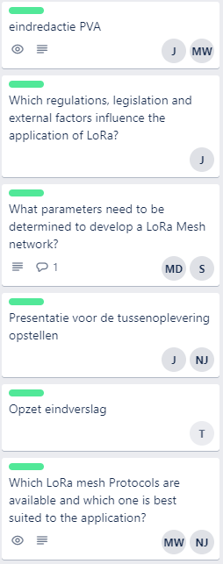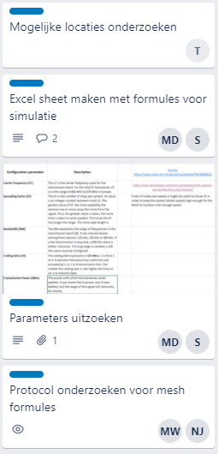

**Sprint Review**

In dit hoofdstuk worden de technische prestaties geëvalueerd. Er wordt gekeken naar welke taken er precies zijn behaald en tot welke user stories deze behoren.

**User Stories**

|  |  |  |
| --- | --- | --- |
| **User Story** | **Behaald** | **Technische kwaliteit** |
| Als product owner wil ik dat er een simulatie gemaakt wordt met de parameters van lora zodat er inzicht ontstaat over het eindproduct. | Er worden onderzoeken uitgevoerd voor het bepalen van de parameters voor de simulatie. Verder worden de mogelijke protocollen onderzocht. | * Parameters uitzoeken * Excel sheet met berekeningen * Protocol onderzoek |
| Als product owner wil ik documentatie van het onderzoek, zodat alle informatie overzichtelijk te vinden is. | Documentatie wordt constant bijgehouden. Deze User Story zal van toepassing zijn bij elke sprint. | * PvA * Regulations * Protocols * Parameters |

**Persoonlijke taken**

|  |  |  |
| --- | --- | --- |
| **Groepslid** | **Taken** | **Voortgang** |
| Stijn Vergouwen | * Excel sheet parameters | Overleg gehad met lead software engineer. Overgestapt naar een ander simulatieprogramma. Parameters zijn duidelijk. |
| Maarten van Dijk | * Excel sheet parameters * Presentatie | Geholpen met simulatie. Presentatie gehouden voor de begeleiders en product owner. |
| Nick Jans | * Protocollen onderzoeken | Verschillende mogelijke protocollen onderzocht en op een rijtje gezet. |
| Jari de Haas | * Presentatie * PvA * Onderzoek wet en regelgeving | Presentatie gegeven. PvA opgeleverd. Informatie over wet en regelgeving op een rijtje gezet. |
| Menno Weijers | * PvA * Protocollen onderzoeken | PvA eindredactie uitgevoerd. Verschillende mogelijke protocollen onderzocht en op een rijtje gezet. |
| Thomas Kinket | * Opzet eindverslag opgesteld * Verschillende gebruik situaties onderzoeken | Opzet gemaakt. Informatie over verschillende situaties duidelijk toegelicht. |

**Burndown Chart**

Onderstaand is de burndown chart van de huidige sprint te zien. De eerste daling van de tijd was bij het geven van de presentatie. De daling aan het eind van de sprint was bij het opleveren van de rest van de producten. Dit is het opleveren van het onderzoek van het protocol, parameters, wet en regelgeving en persona’s. Nu de informatie van deze onderwerpen duidelijk is kunnen er conclusies getrokken worden om de deelvragen te beantwoorden. Dit wordt uitgevoerd in de volgende sprint.

